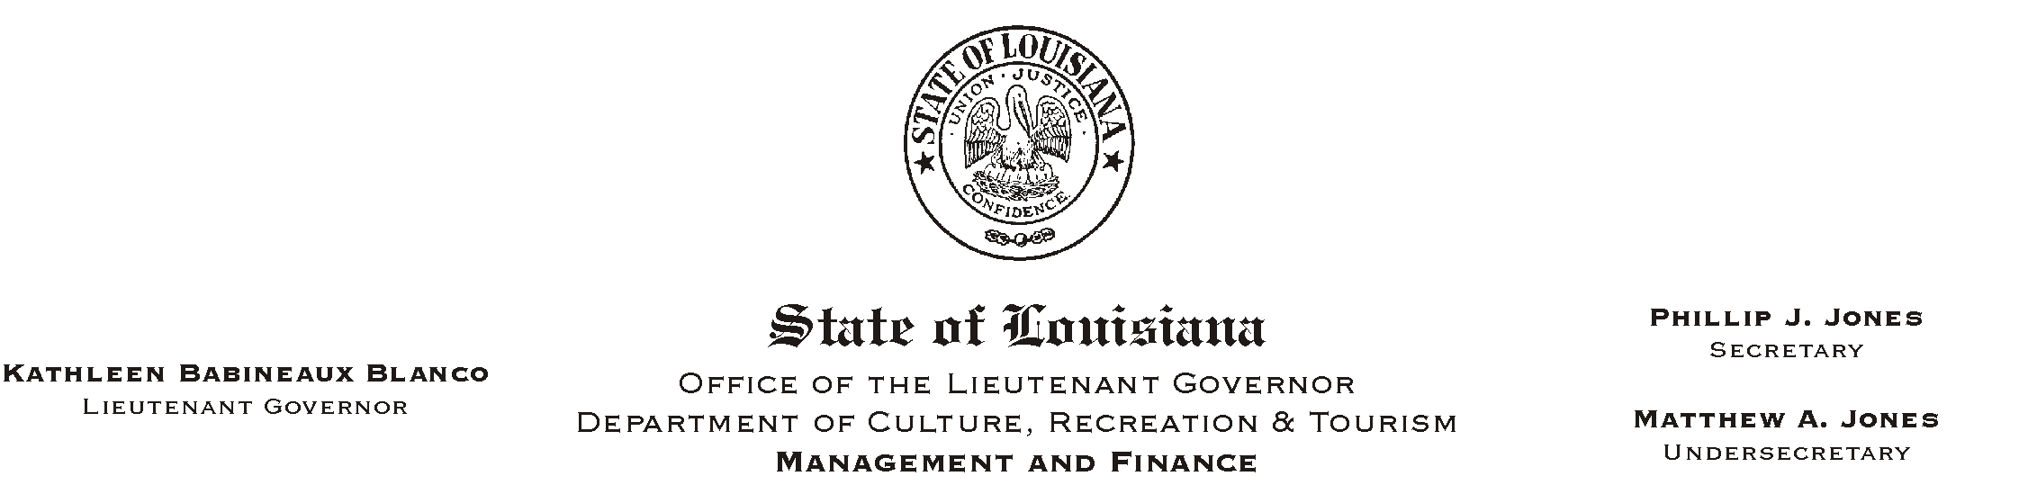
June 5, 2002
HUMAN RESOURCES MEMORANDUM NO. 02-044

TO: Lt. Governor, Secretary, Undersecretary, Assistant Secretaries, Deputy Assistant Secretaries, and Program Managers

FROM: Mary F. Ginn
Human Resources Director

SUBJECT: Human Resources Staff
Please Post and Circulate

The Human Resources Section (HR) of OMF serves the employment and benefits needs of all employees. To help you determine who to call when a particular need occurs, attached is a list of HR staff and each person=s area of expertise. Whereas some of us have general experience in most areas of HR management, others are more specialized.

Please copy and distribute this information to all employees and feel free to call on any of us as needs arise. For your convenience, this list is also posted on Channel Z.

Attachment

