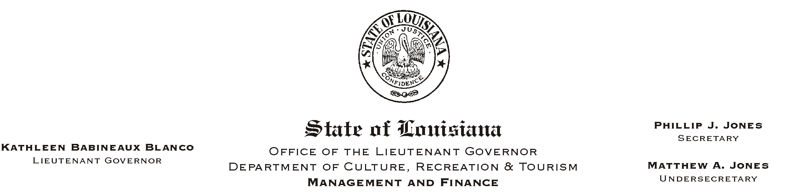
June 10, 2002
HUMAN RESOURCES MEMORANDUM NO. 02-045

TO: Lt. Governor, Secretary, Undersecretary, Assistant Secretaries, Deputy Assistant Secretaries, Program Managers

FROM: Mary F. Ginn
Human Resources Director

SUBJECT: Astroworld and Jazzland Coupons
Please Post and Circulate

Astroworld and Jazzland coupons are now available. See the attached fliers for details.

If you are interested in obtaining a coupon for one of these amusement parks, please call the Human Resources Office at (225) 342-0880.

Attachments

