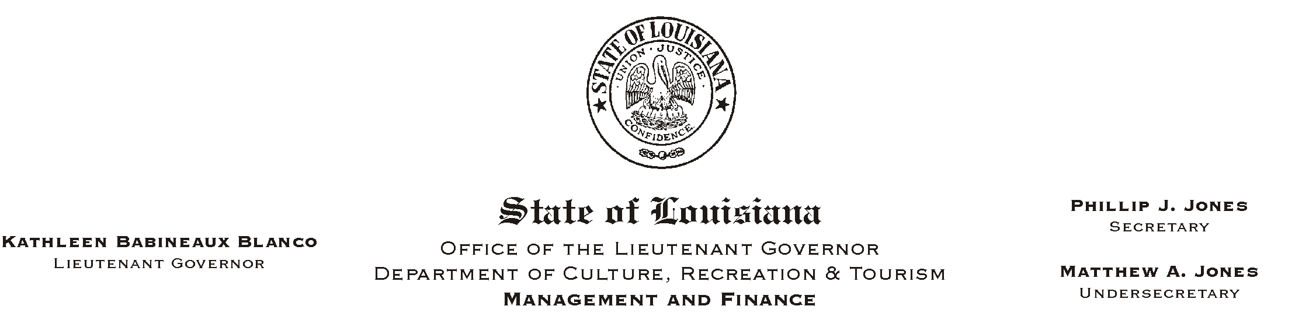
June 12, 2002
HUMAN RESOURCES MEMORANDUM NO. 02-048

TO: Lt. Governor, Secretary, Undersecretary, Assistant Secretaries, Deputy Assistant Secretaries, Program Managers

FROM: Mary F. Ginn
Human Resources Director

SUBJECT: Annual Enrollment Confirmations Mailed
Please Post and Circulate

**PLEASE CIRCULATE AND POST THIS INFORMATION FOR ALL EMPLOYEES**

Confirmations of enrollments and changes in insurance benefits made by employees during the recent Annual Enrollment were mailed today to employees= home addresses. Employees will notice the new insurance rates in their next checks/deposits (June 14, 2002).

Please call the Human Resources Office at (225) 342-0880 if you have any questions.

