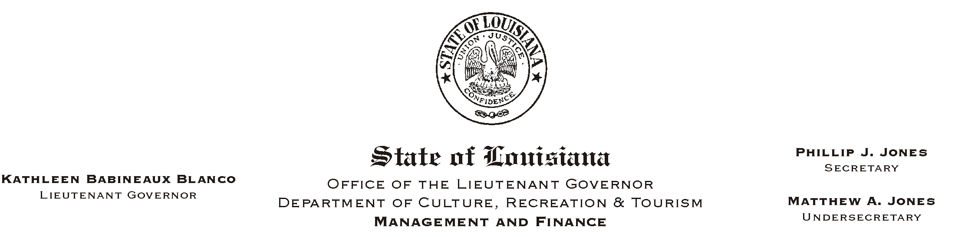
June 17, 2002
HUMAN RESOURCES MEMORANDUM NO. 02-050

TO: Lt. Governor, Secretary, Undersecretary, Assistant Secretaries, Deputy Assistant Secretaries, Program Managers

FROM: Mary F. Ginn
Human Resources Director

SUBJECT: Updated Personnel Data and/or Change Form (OMF-301)
Please Post and Circulate

Attached is an updated version of the form we commonly refer to as the A301 form@ (Personnel Data and/or Change Form). We would like to thank the administrative staff in State Parks who helped with the updating and formatting of this form. It was a real team effort and because of that, I think we have made some changes that will make the form easier to use. (State Parks field offices will be receiving from their headquarters office Acustomized@ versions of the form with certain sections already completed.)

This form will also be available on Channel Z. It can be completed online, and printed for submission to us.

We are also updating the New Hire Checklist and hope to complete it this week. Both the 301 form and the new checklist will be included in our Orientation Training currently being scheduled in field offices over the next few weeks/months. If you have any questions prior to that time, please call the Human Resources Office at (225) 342-0880.

Attachment

