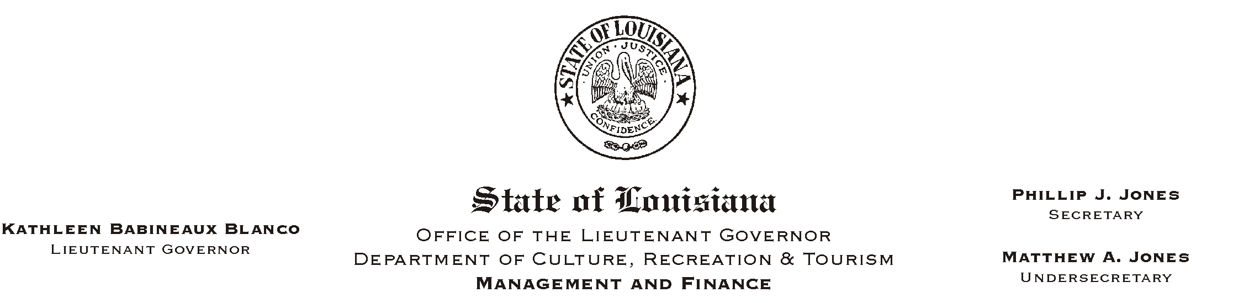
HUMAN RESOURCES MEMORANDUM NO. 02-054

June 25, 2002

TO: Lt. Governor, Secretary, Undersecretary, Assistant Secretaries, Deputy Assistant Secretaries, Program Managers

FROM: Mary F. Ginn
Human Resources Director

SUBJECT: Updated Civil Service Pay Grid

Attached is a correction to the Civil Service Pay Grid that was sent out with Human Resources Memorandum 02-049 on June 12, 2002.

GS-1 through GS-4 have minimums below minimum wage; however, we must pay at least the federal minimum wage to all employees of $5.15 per hour.

If you have any questions, please contact the Human Resources Office at (225) 342-0880.

Attachment
Please Post and Circulate

