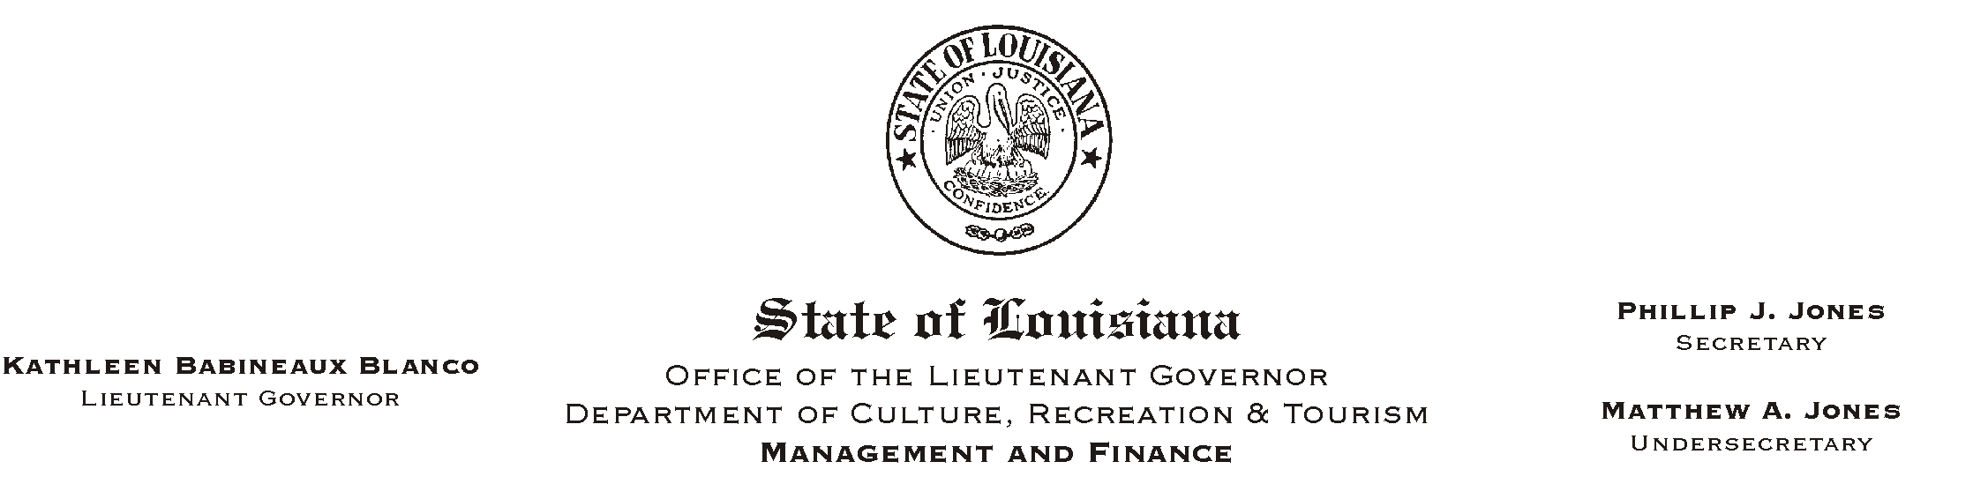
June 27, 2002
HUMAN RESOURCES MEMORANDUM NO. 02-055

TO: Lt. Governor, Secretary, Undersecretary, Assistant Secretaries, Deputy Assistant Secretaries, Program Managers

FROM: Mary F. Ginn
Human Resources Director

SUBJECT: Two Revised Forms:
Please Post and Circulate
ANew Hire Orientation Checklist@ and AEmployee Policy Acknowledgments@

The ANew Hire Orientation Checklist@ and AEmployee Policy Acknowledgments@ forms have been revised and are attached. Please instruct all staff members who are involved in the employee orientation process to remove all outdated forms and begin immediately using the revised forms.

We are in the process of conducting field training on the overall orientation process and new forms. If you have any questions prior to training, please contact Kathleen Miller or Dave Besse at (225) 342-0880.

Attachments

