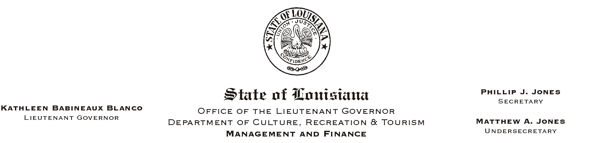
HUMAN RESOURCES MEMORANDUM NO. 02-056

June 28, 2002

TO: Lt. Governor, Secretary, Undersecretary, Assistant Secretaries, Deputy Assistant Secretaries, Program Managers

FROM: Mary F. Ginn
Human Resources Director

SUBJECT: Drug Testing Collection Sites

Recently, several drug tests have been conducted at sites which are not on contract with SECON resulting in the office having to pay for these tests separately from the contract. The cost is greater and we are not authorized to seek services outside of the contract.

Drug testing must be conducted at a site on contract with SECON. Attached is another copy of the SECON Collection Site list.

If you need additional information, please let us know.

Attachment

Please Post and Circulate

