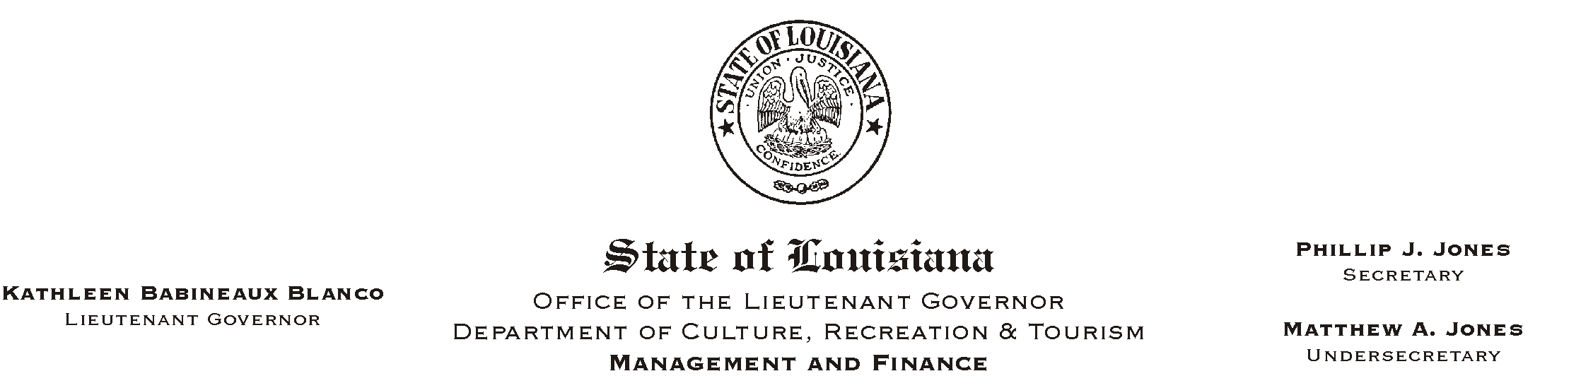
July 3, 2002
HUMAN RESOURCES MEMORANDUM NO. 02-057

TO: Lt. Governor, Secretary, Undersecretary, Assistant Secretaries, Deputy Assistant Secretaries, Program Managers

FROM: Mary F. Ginn
Human Resources Director

SUBJECT: A Lunch & Learn Workshop - Inspirational Writings Bring Comfort
Please Post and Circulate
(Another in our series of informational meetings on health and safety)

Inspirational Writings Bring Comfort
Delta Trabeaux Keith, Author of
AStraight From the Throne@
(A Book of Poetry)

Thursday, August 1, 2002
11:30 a.m. - 12:30 p.m.
Seminar Center, State Library

You are invited to attend a Lunch & Learn Workshop presented by Delta Trabeaux Keith, author of AStraight From the Throne@, a book of inspirational poetry. As we eat lunch, Ms. Keith will share with us how she was inspired to write and how the verses reflect life=s daily challenges.

Employees can order lunch from AGrand Cru@ or bring their own lunch. You must provide your own soft drink. Please notice that this workshop is concurrent with lunch.

This workshop will also serve as a safety meeting relating to health and well being. Please complete the attached registration form and submit it to the Human Resources Office no later than 4:30 p.m., Tuesday, July 30, 2002. Those interested can also register on-line on AChannel Z.@

Attachment

A ALUNCH AND LEARN@ WORKSHOP

Inspirational Writings Bring Comfort
Delta Trabeaux Keith, Author of
AStraight From the Throne@
(A Book of Poetry)

Thursday, August 1, 2002
11:30 a.m. - 12:30 p.m.
Seminar Center, State Library

REGISTRATION FORM
Please Print
Name_________________________________________________________________________

Department__________________________________________ Phone #__________________

_____ Include me in the Box Lunch
*** NOTE: If you are unable to attend after making a reservation and fail to notify us, please understand that we must consider this registration a guarantee for your payment.

Lunch Choices from Grand Cru:

All lunches are $8.00 (including tax). Sandwiches also include chips and cookie.

_____ Highland Turkey Sandwich with Cranberry Horseradish on Seven Grain Bread

_____ Santa Fe Wrap with Grilled Chicken, Roasted Pepper Remoulade, and Avocado

_____ Shrimp Remi with Remoulade, Avocado, and Spring Greens on a Croissant.

_____ Basil Chicken Salad Dressed on Seven Grain Bread

_____ Caesar Salad with Grilled Chicken

Payment Choice:
_____ Check for the lunch amount payable to Grand Cru is attached.
_____ I will pay at the meeting.

OR
_____ I will attend the presentation but will not participate in the lunch.

Signatures:

EMPLOYEE______________________________________________ Date_______________

SUPERVISOR_____________________________________________ Date_______________

