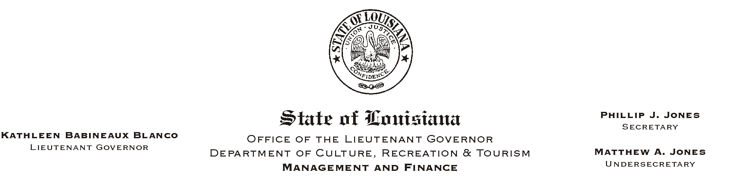
July 3, 2002
HUMAN RESOURCES MEMORANDUM NO. 02-058

TO: Lt. Governor, Secretary, Undersecretary, Assistant Secretaries, Deputy Assistant Secretaries, Program Managers

FROM: Mary F. Ginn
Human Resources Director

SUBJECT: Mandatory Direct Deposit as Condition of Employment Began July 1, 2002
Please Post and Circulate

We just received a revised waiver form (attached) from the Division of Administration (DOA) which must be used for any new employee requesting a waiver to mandatory direct deposit. Effective July 1, 2002, new employees must either be enrolled in direct deposit or have a waiver which has been approved by the appointing authority AND DOA to receive a pay check from the state.

Field offices are instructed to include completed direct deposit forms (and copy of voided check) OR completed waiver forms (with documentation/justification) when new hire paperwork is faxed to Human Resources. Waivers must have supporting documentation attached and appointing authority approval. If field offices fax the waivers to the appointing authorities for signatures, the appointing authorities must forward the signed forms to our office immediately so that DOA approval can be obtained prior to the end of the pay period.

Please note that the new AConditional Offer of Employment@ form distributed last week also went into effect for all offers beginning July 1, 2002. Although those who were offered employment prior to July 1, 2002 will not have a AConditional Offer@ form, the requirement for enrollment in direct deposit or an approved waiver is still a condition of employment. Once again, no checks will be issued by DOA for employees who are not in compliance with this new state rule.

Please call the Human Resources Office at (225) 342-0880 if you have any questions.

Attachment

