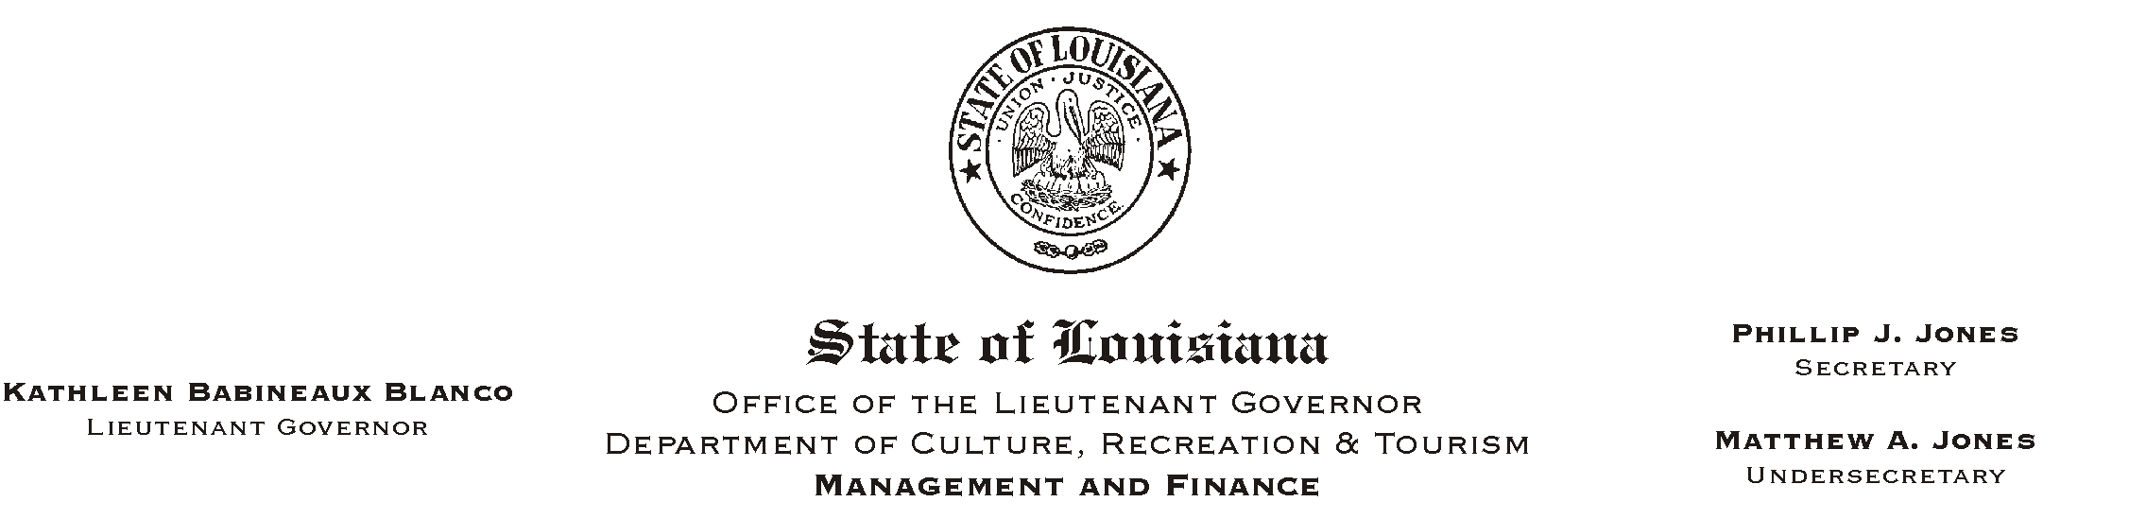
HUMAN RESOURCES MEMORANDUM NO. 02-061

July 17, 2002

TO: Lt. Governor, Secretary, Undersecretary, Assistant Secretaries, Deputy Assistant Secretaries, Program Managers

FROM: Mary F. Ginn
Human Resources Director

SUBJECT: Post-Accident Testing

In view of recent events, I ask that each of you again review the section within our Substance Abuse and Drug-Free Workplace Policy addressing Post-Accident/Incident drug and alcohol testing, which states:

“Post-Accident/Incident: Any employee directly involved in an on-duty accident shall be required to submit to drug and alcohol testing if:

a) The accident involves circumstances giving rise to a reasonable suspicion that the accident may have involved the employee’s drug or alcohol use and the employee’s action or inaction may have been a causative factor;

b) The accident meets the criteria of paragraph (a) and results in or causes the release of hazardous waste as defined by La. R.S. 30:2173(2) or hazardous materials as defined by La. R.S. 32:1502(5); or

c) The accident results in a fatality or serious bodily injury.

‘Reasonable suspicion’ is a belief, based upon reliable, objective and articulable facts derived from direct observation of specific physical and behavioral characteristics (behavior, speech, appearance, odor), which causes a prudent person to suspect that an employee has engaged in drug or alcohol use.

Only an appointing authority shall require an employee to submit to post-accident/incident testing. Generally, this decision will be based upon the recommendation of supervisory personnel at the scene who have objectively and thoroughly reviewed the circumstances of the accident/incident. The supervisor will fully document the facts upon which the recommendation for testing is made.”

HR Memo 02-061
July 16, 2002
Page 2

Consideration of the right to drug/alcohol test as a result of an accident or incident which satisfies the criteria set forth above is important in view of the prohibition set forth in this state’s worker’s compensation law which prohibits the receipt of worker’s compensation benefits by any employee who tests positive for prohibited drug/alcohol in any post-accident/incident situation. In those cases in which such testing is permitted, denial of worker’s compensation benefits could save this state considerable sums as well as reduce this department’s risk analysis rating.

Be reminded that only an appointing authority can order such testing. Also, remember to immediately contact Gerald Ganey, Safety Director, regarding all accidents/injuries and drug/alcohol testing situations for guidance. If you cannot reach Gerald, please contact me.

Please Post and Circulate

