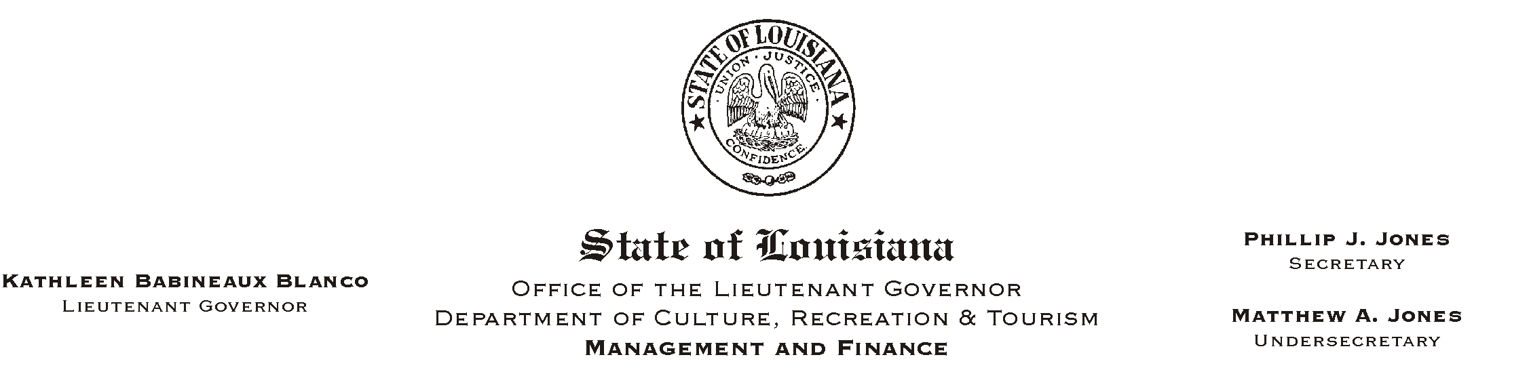
HUMAN RESOURCES MEMORANDUM NO. 02-062

July 17, 2002

TO: Lt. Governor, Secretary, Undersecretary, Assistant Secretaries, Deputy Assistant Secretaries, Program Managers

FROM: Mary F. Ginn
Human Resources Director

SUBJECT: Random Drug Testing

In accordance with express law and this Department’s Substance Abuse and Drug-Free Workplace Policy, employees holding safety-sensitive positions are required to be tested on a random basis. Currently the positions deemed to be “safety-sensitive” have been identified in Appendix “A” attached to our testing policy.

It is time to review and probably revise the listing of positions satisfying the safety-sensitive criteria, especially in view of certain equipment purchases by various parks. As such, I ask that you provide a listing of all positions, along with the employees incumbering the position, who:

- Serve in law enforcement capacity and/or carry a weapon;
- Participate in historic reenactments or demonstrations involving the use of black powder or other weaponry;
- Regularly operate moving equipment (other than small riding lawnmowers);
- Regularly operate automobiles/ trucks;
- Regularly operate power equipment such as chain saws, lathes, power tools and other such potentially dangerous equipment.

Please respond to this request by August 1, 2002. Upon receipt of this information, we will re-issue the listing of positions to be included in the pool for random drug testing.

Please Post and Circulate

