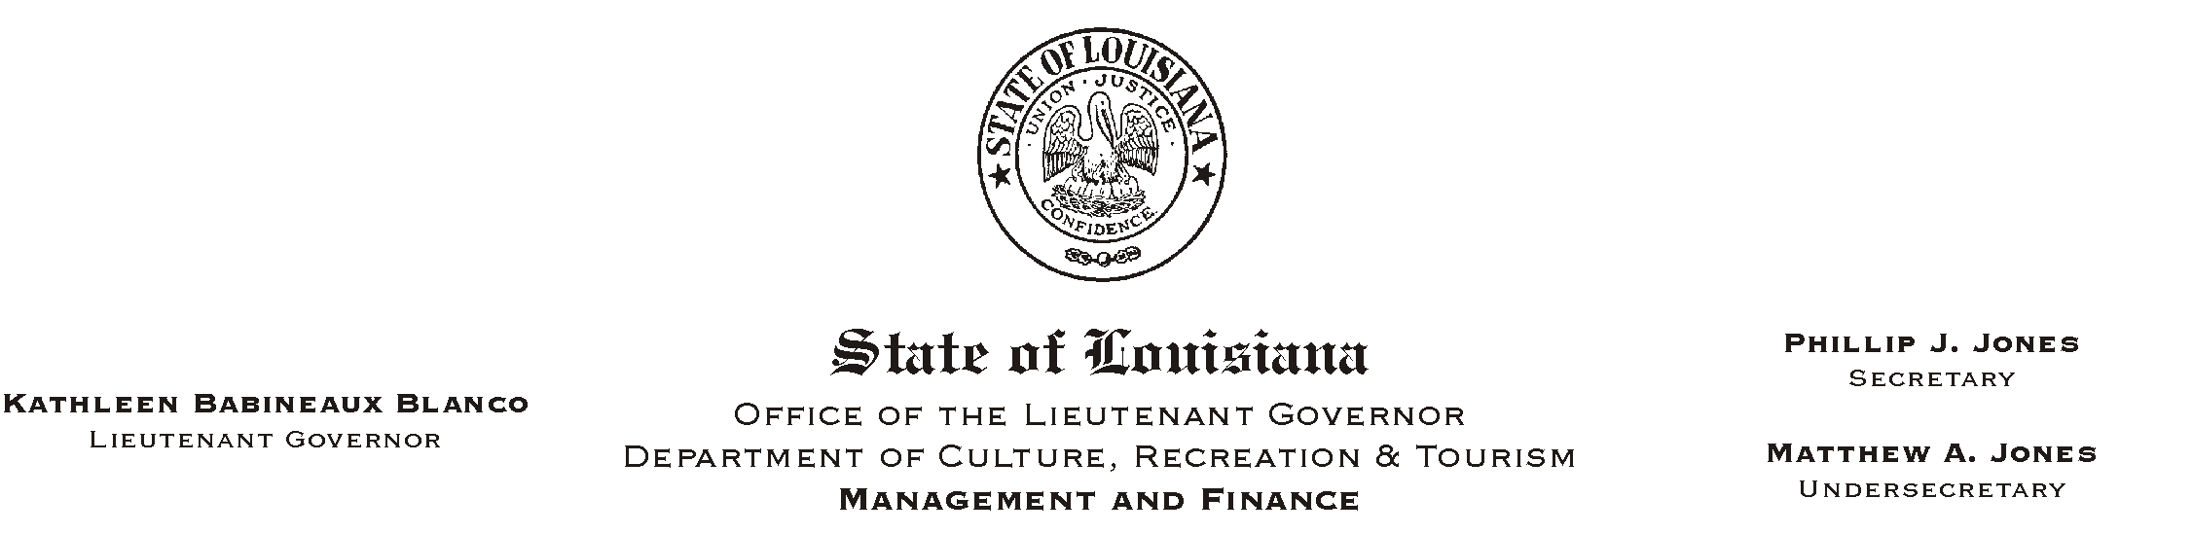
July 23, 2002
HUMAN RESOURCES MEMORANDUM NO. 02-063

TO: Lt. Governor, Secretary, Undersecretary, Assistant Secretaries, Deputy Assistant Secretaries, Program Managers

FROM: Mary F. Ginn
Human Resources Director

SUBJECT: Establishing and Maintaining Eligibility for Promotions
Please Post and Circulate

This is a reminder to all employees that it is the employee=s responsibility to establish and maintain personal eligibility for promotional opportunities in state government. Many Civil Service jobs require special announcements before applications will be accepted. Other jobs are continuously announced and applications are accepted at any time by Civil Service.

When a vacancy occurs at CRT for a job that is continuously announced by Civil Service, the Human Resources Office will request a list of available applicants from Civil Service. Employees who have maintained current grades will appear on the list and be considered for the promotional opportunity. Employees who have not maintained current grades will miss the opportunity for consideration. It is therefore essential for employees to apply for higher level jobs, including those in a training series, as they become qualified to insure having a current grade when a vacancy occurs.

Employees may check the qualifications and testing requirements for all Civil Service jobs on the Civil Service web site, www.dscs.state.la.us or call the Human Resources Office for information at (225) 342-0880.

