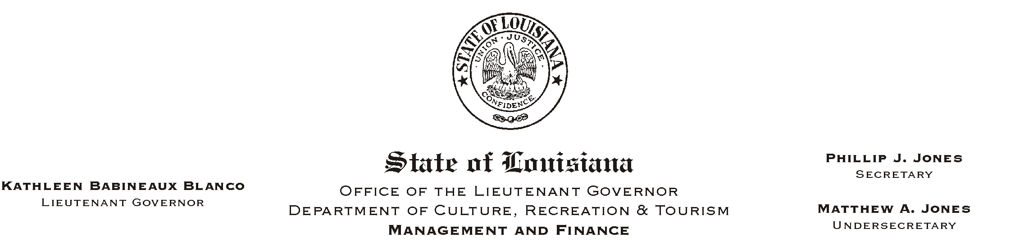
July 23, 2002
HUMAN RESOURCES MEMORANDUM NO. 02-064

TO: Lt. Governor, Secretary, Undersecretary, Assistant Secretaries, Deputy Assistant Secretaries, Program Managers

FROM: Mary F. Ginn
Human Resources Director

SUBJECT: Job Offers to Permanent Employees
Please Post and Circulate

In a continuing effort to insure that all prospective employees are properly informed prior to accepting a conditional offer of employment, the attached policy has been developed to specifically address the procedures which must be followed when offering a probationary appointment to a permanent employee.

The policy requires that the status and salary of the proposed appointment be clearly communicated at the time of the job offer and that a APre-Employment Statement of Acceptance@ (also attached) be signed by the applicant. Please note that the requirement for a signed acceptance statement is also referenced in item #4 on the new Conditional Offer of Employment form recently implemented.

If you have any questions, please call the Human Resources Office at (225) 342-0880.

Attachments

