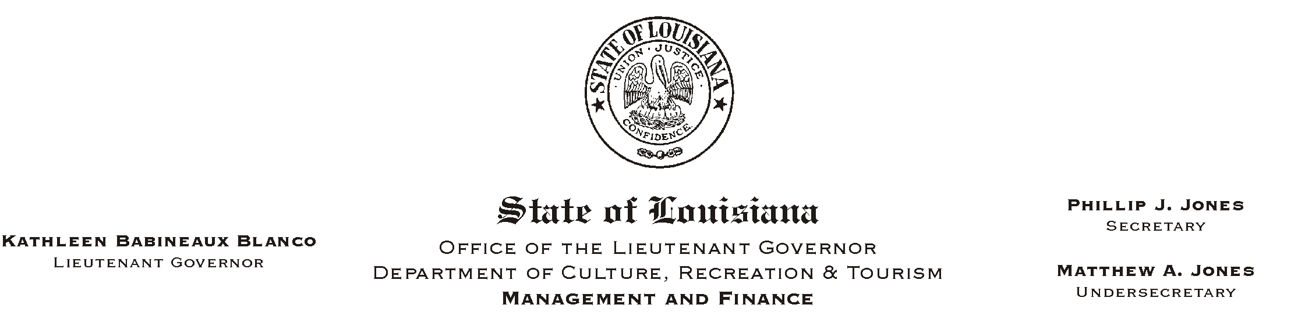
August 19, 2002
HUMAN RESOURCES MEMORANDUM NO. 02-072

TO: Lt. Governor, Secretary, Undersecretary, Assistant Secretaries, Deputy Assistant Secretaries, Program Managers

FROM: Mary F. Ginn
Human Resources Director

SUBJECT: Governmental Ethics Seminar
Please Post and Circulate

A seminar on Governmental Ethics will be presented for OLG and CRT management by Kristen Spring, Attorney, representing the Louisiana Board of Ethics Administration. Details are as follows:

Governmental Ethics Seminar
August 29, 2002, 10:00 a.m.
Secretary=s Conference Room
Capitol Annex, 3rd Floor

Please RSVP by e-mail to mginn@crt.state.la.us. A copy of the outline of information to be covered in the seminar is attached.

Attachment

