HUMAN RESOURCES MEMORANDUM NO. 02-075
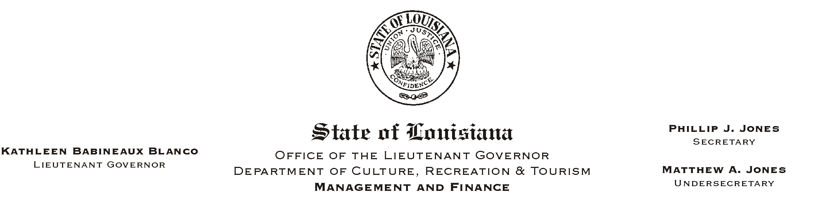

August 23, 2002

TO: Lt. Governor, Secretary, Undersecretary, Assistant Secretaries, Deputy Assistant Secretaries, Program Managers

FROM: Mary F. Ginn
Human Resources Director

SUBJECT: REVISED PPR FORM

Attached is a copy of the new Performance Planning and Review Form. Beginning today, everyone should start using this new PPR form.

There are no major changes to the new form except the first page which has been revised to include additional information. A breakdown is as follows:

- The form no longer requires the use of the employee’s Social Security Number; it will now require the employee’s personnel number.
- If an employee receives an un-rated, you must select the exact reason for the un-rated score.
- The personnel number and printed or typed name is required along with the signature of the rating supervisor.

The rest of the changes are very minor. Some of the instructions have been revised to be more helpful. The Microsoft Word version of the form has been formatted for more user-friendly navigation. A supplemental blank page has also been added to provide space for continuation of performance expectations or comments.

Planning sessions that have been completed on the old form should be rated on the old form and the first page of the old form replaced with the first page of the new form. As of today, any new planning sessions should be completed on the new form.

Please contact Heather Sherlock in the Human Resources Office at (225) 219-4331 with questions.
Please Post and Circulate

Attachment

