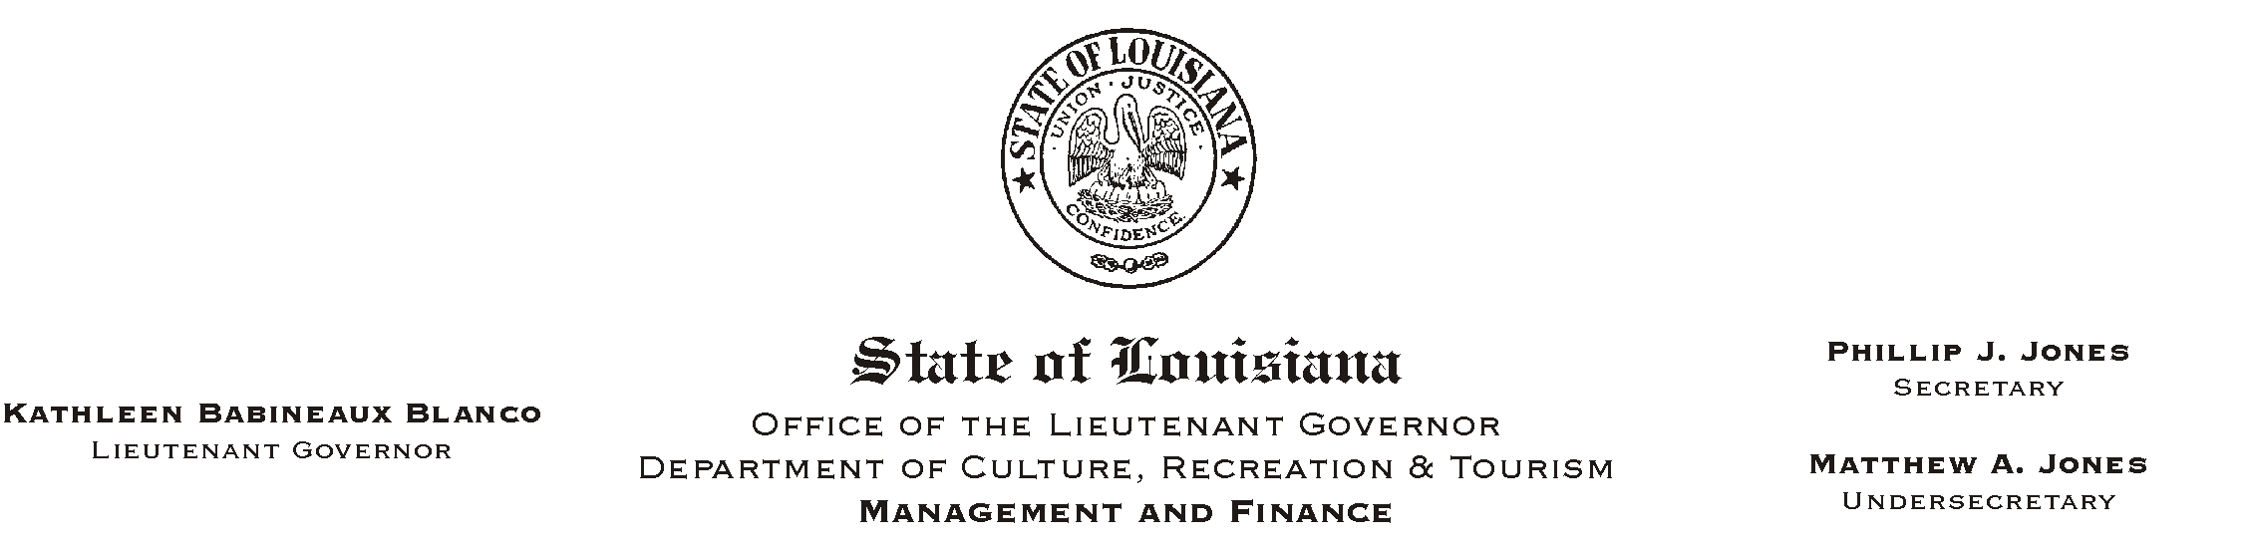
September 5, 2002
HUMAN RESOURCES MEMORANDUM NO. 02-077

TO: Lt. Governor, Secretary, Undersecretary, Assistant Secretaries, Deputy Assistant Secretaries, Program Managers, and All Employees

FROM: Mary F. Ginn
Human Resources Director

SUBJECT: AAll American Lunch@ - In Memory of the Events of 9/11
Please Post and Circulate

Employees are invited to join together for an AAll American Lunch@ to commemorate the events of 9/11/01 when Athe best of humanity met the worst of humanity.@

Hot Dogs w/Chili and Apple Pie A-La-Mode
Wednesday, September 11, 2002, 11:30 a.m.
Capitol Annex Lobby - First Floor
$5.00 per person, Pre-Registration Required

To register, please fax this form to (225) 342-7928 or hand deliver to the HR Office no later than 11:00 a.m., Tuesday, September 10. Casual or patriotic dress has been approved by appointing authorities for September 11th. However, please refer to your office=s dress code for specific prohibitions regarding casual dress.

PRINT NAME_______________________________________AGENCY____________________

PHONE #________________________________E-MAIL _______________________________

NOTE: If you are unable to attend after making a reservation and fail to notify us, please understand that we must consider this registration a guarantee for your payment. Please pay at the door with the correct cash amount or by check made out to cash.

__________________________________________________
Employee Signature Date

