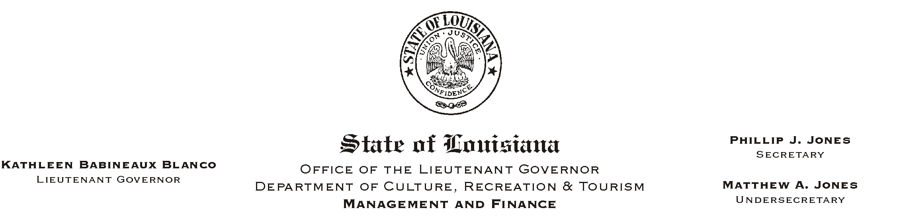
September 19, 2002
HUMAN RESOURCES MEMORANDUM NO. 02-081

TO: Lt. Governor, Secretary, Undersecretary, Assistant Secretaries, Deputy Assistant Secretaries, Program Managers

FROM: Mary F. Ginn
Human Resources Director

SUBJECT: Policy on AWorkplace Harassment/Discrimination@ (Action Required)
Please Post and Circulate

The attached policy on AWorkplace Harassment/Discrimination@ dated September 1, 2002, is a revision to the original policy which was developed January 11, 2001 and used in training. The revision is more inclusive and must be included in all CRT new hire orientation programs. Please destroy the original AWorkplace Harassment Policy@ dated January 11, 2001.

Field offices that are authorized to conduct orientation must add the revised policy (attached) to their programs. The New Hire Checklist and Employee Policy Acknowledgment forms have also been updated to include this policy and are being forwarded as attachments to Human Resources Memorandum No. 02-084.

Please make copies of this policy and distribute to all employees. The employee acknowledgment form at the end of the policy must be signed by each employee and returned to the Human Resources Office no later than Friday, October 4, 2002. New employees who receive the policy as part of their orientation will only need to sign the comprehensive Employee Policy Acknowledgment form which acknowledges receipt of all policies discussed during orientation.

If you have any questions concerning this policy, do not hesitate to call the Human Resources Office at (225) 342-0880.

Attachment

