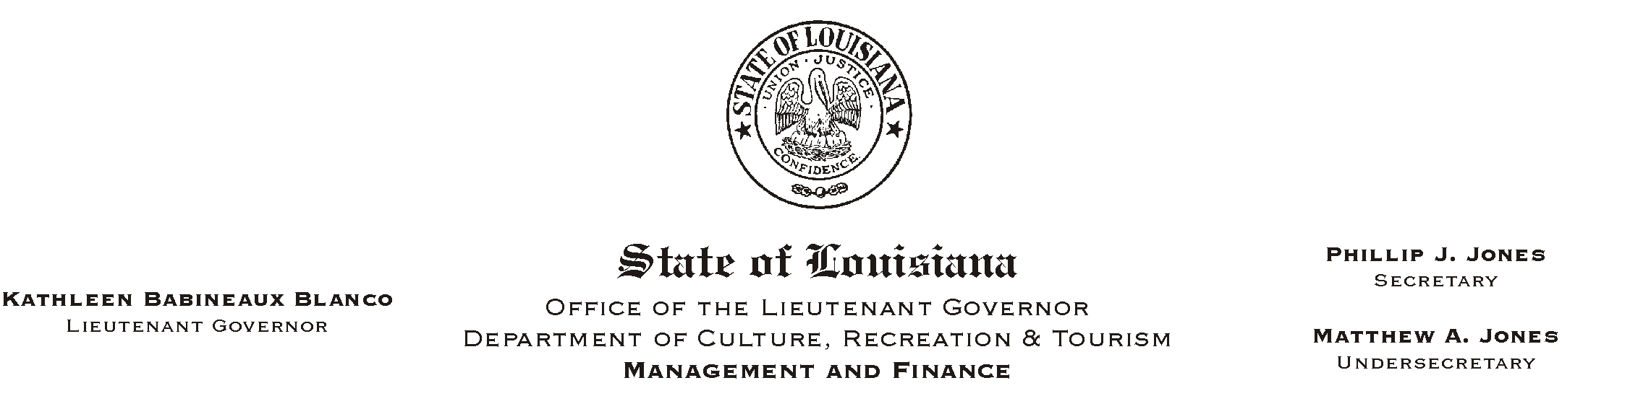
September 19, 2002
HUMAN RESOURCES MEMORANDUM NO. 02-083

TO: Lt. Governor, Secretary, Undersecretary, Assistant Secretaries, Deputy Assistant Secretaries, Program Managers

FROM: Mary F. Ginn
Human Resources Director

SUBJECT: Policy on ADirect Deposit of Employees= Pay@
Please Post and Circulate

Effective July 1, 2002, direct deposit of employees= pay was made a Acondition of employment@ by the Division of Administration. We developed a AConditional Offer of Employment@ form that was released to all offices on June 25, 2002 by HR Memo #02-053. The new requirements were explained at that time, by e-mail on July 9, 2002, and again on July 11, 2002 with a revision of the form transmitted by HR Memo #02-060.

When the AConditional Offer of Employment@ form was released, you were informed that it was part of a departmental policy that was under development and has now been finalized. We hope that the policy will provide even further clarification of this requirement.

Most of our offices have become proficient in completing the AConditional Offer of Employment@ form and explaining it thoroughly to prospective employees. However, some still need to be reminded that this form MUST be completed prior to hiring any employee which includes regular hires, wage workers, students, etc. Anyone who receives a paycheck from the state must be given a Aconditional@ offer in advance of hiring to be sure they understand, before they are hired, the requirements of passing a drug test, receiving their pay through direct deposit, providing proper identification, etc.

Please call the Human Resources Office if you have any questions.

Attachment

