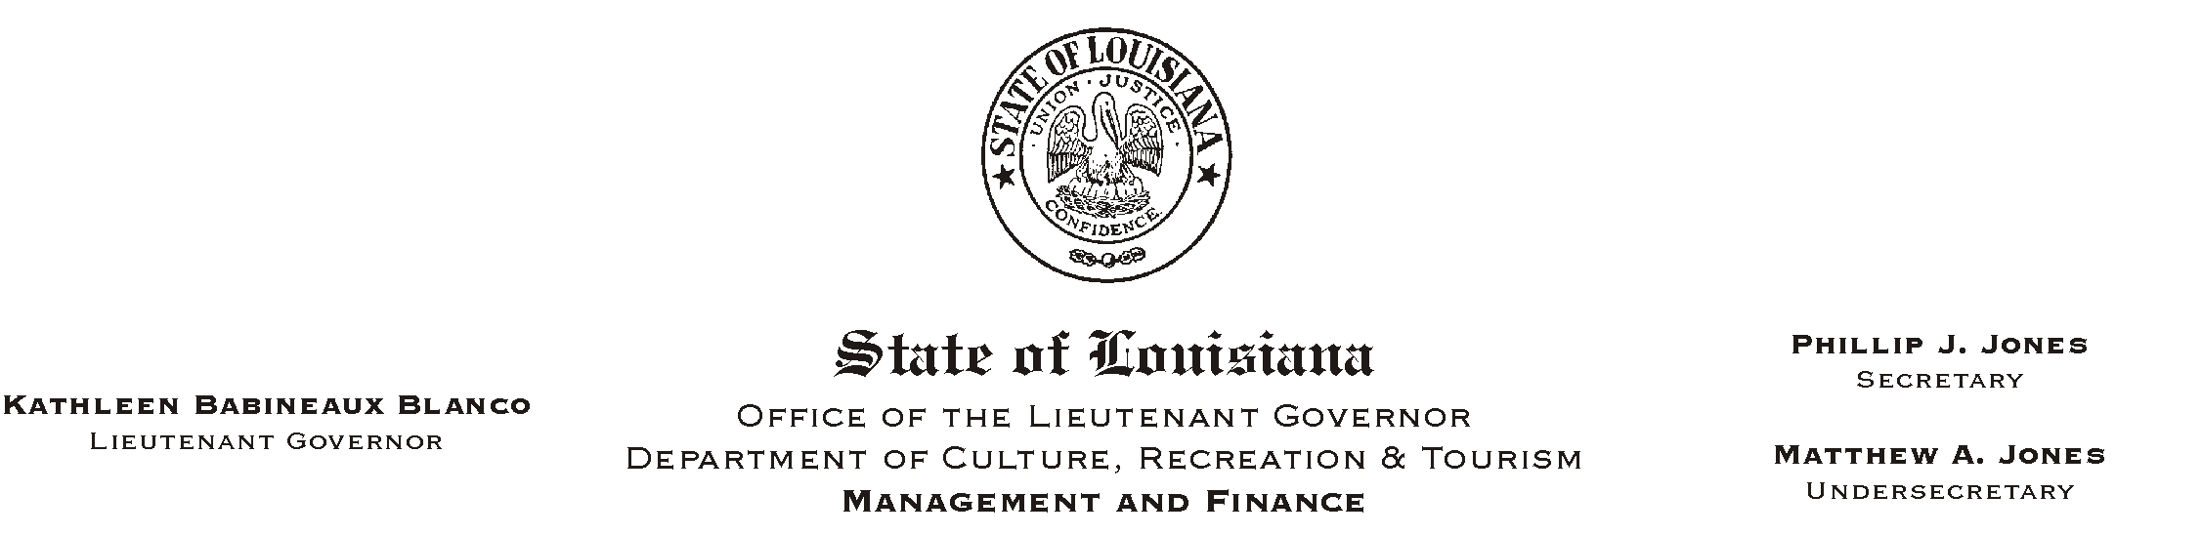
October 4, 2002
HUMAN RESOURCES MEMORANDUM NO. 02-089

TO: Lt. Governor, Secretary, Undersecretary, Assistant Secretaries, Deputy Assistant Secretaries, Program Managers

FROM: Mary F. Ginn
Human Resources Director

SUBJECT: Garnishment Procedures
Please Post and Circulate

Prior to the Regular Legislative Session of 2001, petitions for garnishments against employees= wages, salaries, and commissions were served by deputies to individual state agency sites. Beginning August 1, 2001, the procedure was changed by Act No. 250 (attached) which requires all garnishments on the wages of state employees paid by the Office of Statewide Uniform Payroll (OSUP) to be served only to that office in Baton Rouge. Authorities were notified by OSUP of the change back in 2001.

We are experiencing occasional situations where garnishments are being served by authorities to local and field offices where they are then forwarded to the Human Resources Office. Although we in turn forward them on to OSUP, we have been notified that this process is not in compliance with the current law and that we must not continue to accept the garnishments when served.

If anyone comes to your office or site and attempts to serve a petition for the garnishment of an employee=s wages, you must not accept it. Please make all of your employees aware of this process and instruct them to give the person serving the papers a copy of the attached flier which contains the information they will need for the proper service of the garnishment.

Please do not hesitate to call if you have any questions.

Attachments

INSTRUCTIONS FOR SERVING GARNISHMENTS

Excerpt from Act No. 250, Section 1, Paragraph B:

AService of garnishment petitions against the wages, salaries, or commissions of employees employed within the executive branch of state government shall be made in the following manner: (1) For employees paid through the Office of Statewide Uniform Payroll of the Division of Administration, service shall be made on the said office.@

This requirement applies to all agencies within the Department of Culture, Recreation and Tourism. Garnishment petitions must be served to:

Jena W. Cary, Director
Office of Statewide Uniform Payroll
Division of Administration
1201 North 3rd St., Suite 6-150
Baton Rouge, LA 70802

Please call (225) 342-5332 for more information.

