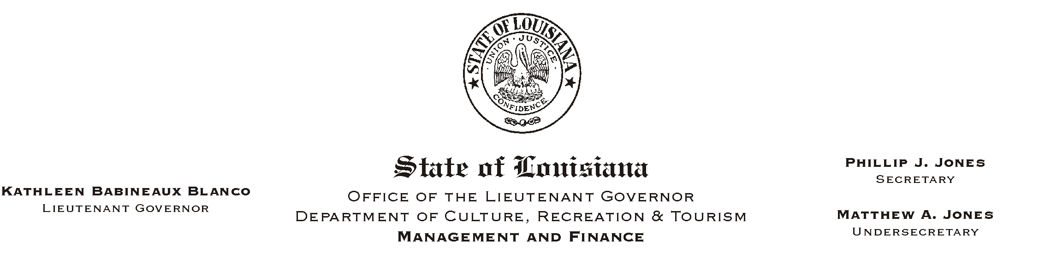
October 21, 2002
HUMAN RESOURCES MEMORANDUM NO. 02-091

TO: Lt. Governor, Secretary, Undersecretary, Assistant Secretaries, Deputy Assistant Secretaries, Program Managers

FROM: Mary F. Ginn, Human Resources Director

SUBJECT: A Lunch & Learn Workshop
Please Post and Circulate
(Another in our series of informational meetings on health and safety)

ALifetime Estate Planning@
Paul A. Rabalais, Attorney, The Rabalais Law Firm
Wednesday, November 6, 2002, 11:30 a.m. - 1:00 p.m.
Seminar Center, State Library

You are invited to attend a Lunch & Learn Workshop presented by Attorney Paul Rabalais on ALifetime Estate Planning.@ Mr. Rabalais is a graduate of the LSU Law Center and received his Masters of Law in Taxation from Boston University School of Law. He and his firm monitor and maintain over two thousand estate plans for Louisiana residents.

Mr. Rabalais will share valuable information about wills, trusts, powers of attorney, and living wills. He will also address the top ten questions estate planning lawyers are asked and much more.

Employees can order lunch from AGrand Cru@ or bring their own lunch. You must provide your own soft drink. We encourage you, if possible, to pay by check.

This workshop will also serve as a safety meeting relating to health and well being. Experts agree that having one=s business affairs in order lowers stress and improves the quality of life. Please complete the attached registration form and submit it to the Human Resources Office no later than noon on Tuesday, November 5, 2002. Registrations can also be made on-line on AChannel Z.@ The same deadline applies for cancellations which must be phoned in to us at (225) 342-0880.
Attachment

A ALUNCH AND LEARN@ WORKSHOP

ALifetime Estate Planning@

Paul A. Rabalais, Attorney, The Rabalais Law Firm
Wednesday, November 6, 2002, 11:30 a.m. - 1:00 p.m.
Seminar Center, State Library

REGISTRATION FORM
Please Print
Name_________________________________________________________________________

Department__________________________________________ Phone #__________________

_____ Include me in the Box Lunch
*** NOTE: If you are unable to attend after making a reservation and fail to notify us, please understand that we must consider this registration a guarantee for your payment.

Lunch Choices from Grand Cru:

All lunches are $8.00 (including tax). Sandwiches also include chips and cookie.

_____ Highland Turkey Sandwich with Cranberry Horseradish on Seven Grain Bread

_____ N=Awlins Beef Brisket, Swiss Cheese, Raspberry Vinaigrette Slaw, Mustard on French Bread

_____ Shrimp Remi with Remoulade, Avocado, and Spring Greens on a Croissant

_____ Muffaletta Genoa Salami, Ham, Mortadella, Provolone, Olive Salad on Italian Loaf (Half)

_____ Caesar Salad with Grilled Chicken

Payment Choice:
_____ Check for the lunch amount payable to Grand Cru is attached.
_____ I will pay at the meeting (please pay by check)
OR
_____ I will attend the presentation but will not participate in the lunch.

Signatures:

EMPLOYEE______________________________________________ Date_______________

SUPERVISOR_____________________________________________ Date_______________

