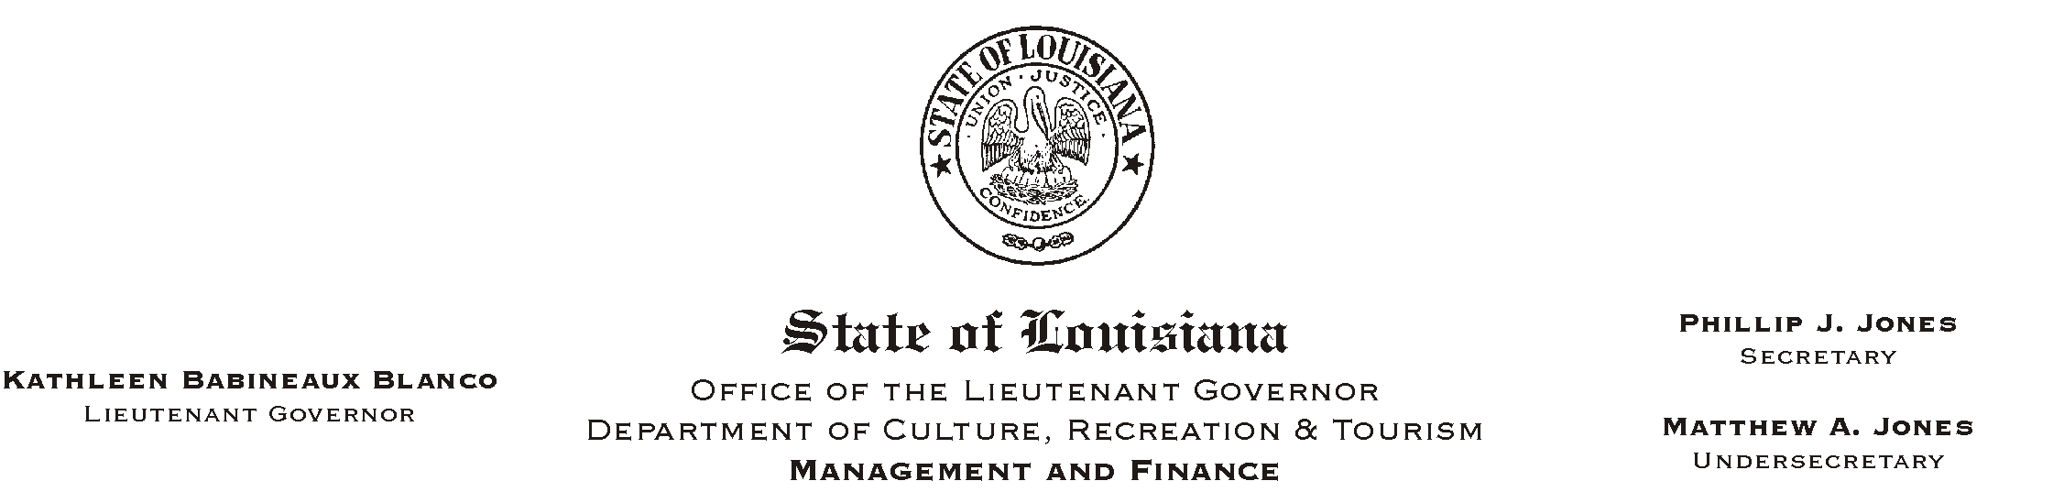
October 28, 2002
HUMAN RESOURCES MEMORANDUM NO. 02-093

TO: Lt. Governor, Secretary, Undersecretary, Assistant Secretaries, Deputy Assistant Secretaries, Program Managers

FROM: Mary F. Ginn
Human Resources Director

SUBJECT: Upcoming Holidays
Please Post and Circulate

The following is a list of upcoming holidays. Some of the holidays are statutory and others have been proclaimed by the Governor.

November 5 Election Day Statutory
November 11 Veterans Day Statutory
November 28 Thanksgiving Day Statutory
November 29 Acadian Day Proclaimed
December 25 Christmas Day Statutory
December 26 Day After Christmas Proclaimed
January 1 New Year=s Day Statutory
January 2 Day After New Year=s Proclaimed

Please notify all employees. If you have any questions, please call the Human Resources Office at (225) 342-0880.

