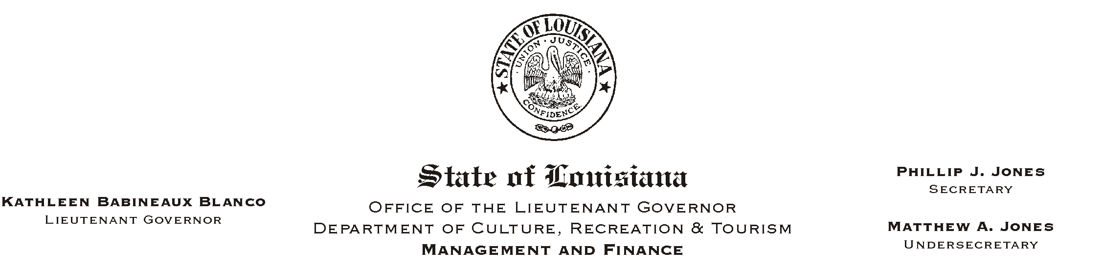
HUMAN RESOURCES MEMORANDUM NO. 02-097

November 8, 2002

TO: Lt. Governor, Secretary, Undersecretary, Assistant Secretaries, Deputy Assistant Secretaries, Program Managers

FROM: Mary F. Ginn
Human Resources Director

SUBJECT: 2002 United Way Campaign Final Report

We did it once again! Thanks to all of you, our campaign was a success and lots of fun.

Please Post and Circulate

The following is a breakdown of our total contributions:

Pledges $8354.32
One-time Cash Donations 246.00
Special Events
- Jambalaya Cookout 1534.41
- Silent Auction 820.00
- White Elephant Auction and Lunch 1347.84
- Bake Sale and Grab Bags 375.10
 Casual Day 220.00
 Raffle Tickets 705.00
 Book Fair 278.90

TOTAL $13,881.57

