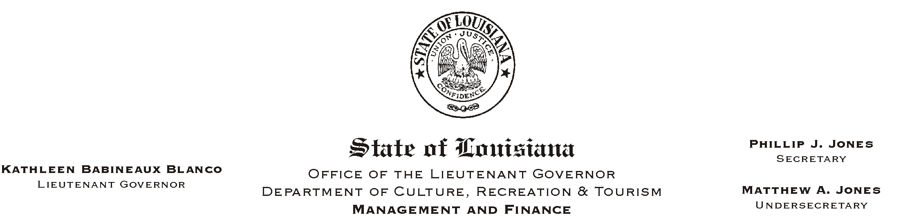
November 8, 2002
HUMAN RESOURCES MEMORANDUM NO. 02-099

TO: Lt. Governor, Secretary, Undersecretary, Assistant Secretaries, Deputy Assistant Secretaries, Program Managers

FROM: Mary F. Ginn
Human Resources Director

SUBJECT: Job Search on the Civil Service Web Site
Please Post and Circulate

Civil Service discontinued publishing Special Announcements some time ago and now publishes job vacancies only on the Civil Service web site under AJob Search.@ Some jobs are required to be published and others are optional (shortage categories and continuously announced jobs).

If you are having recruiting problems for any of your job vacancies, let us know and we can post the vacancies on AJob Search.@ This is an excellent recruiting tool and has the potential to reach job applicants world wide.

Attached is an example of how the postings look on the web. There is an area at the bottom where we can list any special requirements (work schedules, shifts, etc.) that you determine would be helpful or necessary.

Please call Jan Ramezan at (225) 342-8205 or 342-0880 if you have any questions or would like to request a specific vacancy to be announced.

Attachment

