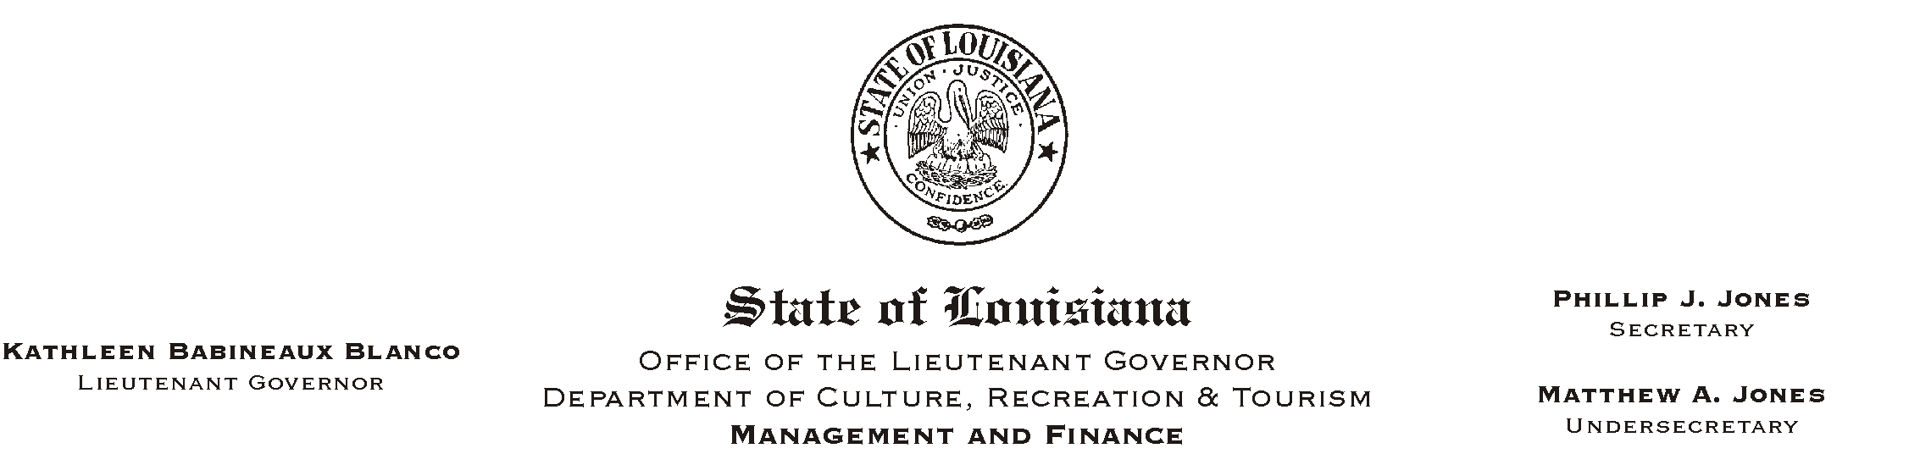
HUMAN RESOURCES MEMORANDUM NO. 02-103

December 2, 2002

TO: Lt. Governor, Secretary, Undersecretary, Assistant Secretaries, Deputy Assistant Secretaries, Program Managers

FROM: Mary F. Ginn
Human Resources Director

SUBJECT: Corrections to the Protective Services Pay Schedule

Attached is a corrected Protective Services (PS) Pay Schedule. The original PS schedule was sent out with Human Resources Memorandum No. 02-096 on November 8, 2002.

Due to rounding of the monthly salaries, the yearly salaries were miscalculated. Civil Service now requires that all yearly and bi-weekly salaries be figured from hourly amounts and not monthly amounts. This causes the yearly, when calculated from the monthly salaries, to be slightly different.

If you have any questions, please contact the Human Resources Office at (225) 342-0880.

Attachment

Please Post and Circulate

