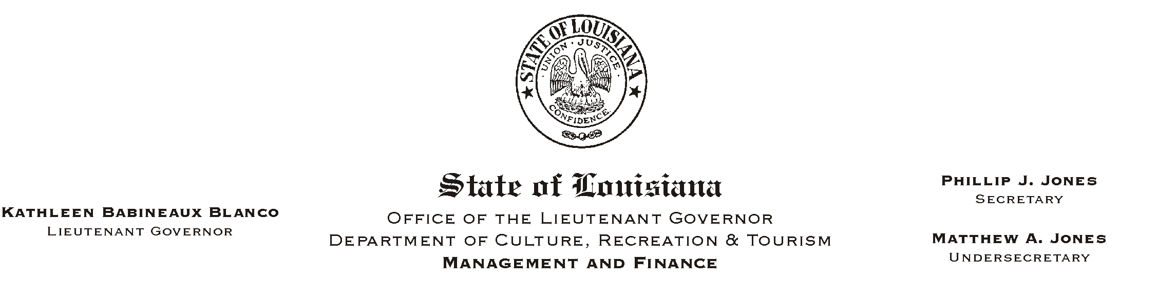
December 10, 2002
HUMAN RESOURCES MEMORANDUM NO. 02-106

TO: Lt. Governor, Secretary, Undersecretary, Assistant Secretaries, Deputy Assistant Secretaries, Program Managers

FROM: Mary F. Ginn
Human Resources Director

SUBJECT: Exit Interview Report Form
Please Post and Circulate

We have redesigned the exit interview form to include more information. Please begin immediately using the attached form. The form is also available on Channel Z.

Prior to an employee leaving the department, either by leaving state service or by transferring to another agency, the employee and the employee=s supervisor must both complete part of the exit interview form. It is very important for the supervisor to collect any state property that has been in the possession of the employee such as keys, ID cards, and credit cards. These items and many more are listed on the form and must be checked off when returned.

This form is also designed to collect information about the employee=s leaving CRT so that our records accurately reflect the circumstances. Although the form is self explanatory, please call the Human Resources Office if you have any questions or if you have an employee who leaves without completing the form.

Attachment

