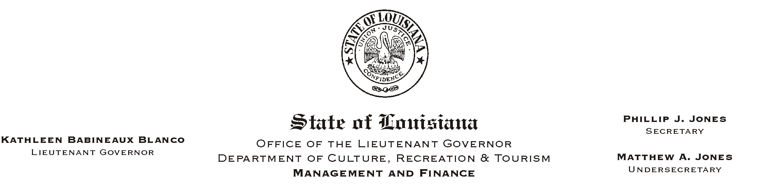
December 10, 2002
HUMAN RESOURCES MEMORANDUM NO. 02-108

TO: Lt. Governor, Secretary, Undersecretary, Assistant Secretaries, Deputy Assistant Secretaries, Program Managers

FROM: Mary F. Ginn
Human Resources Director

SUBJECT: Hand Washing Signs
Please Post and Circulate

New signs are being posted in the restrooms of our offices in the Capitol Annex Building reminding employees to wash hands (with soap) before returning to work. Employees are asked to cooperate with this requirement to help eliminate the spread of disease, especially during the cold and flu season when our immune systems may be compromised.

All CRT offices statewide are also encouraged to copy the attached signs and post in restrooms. If signs are already posted, please disregard.

Attachment

