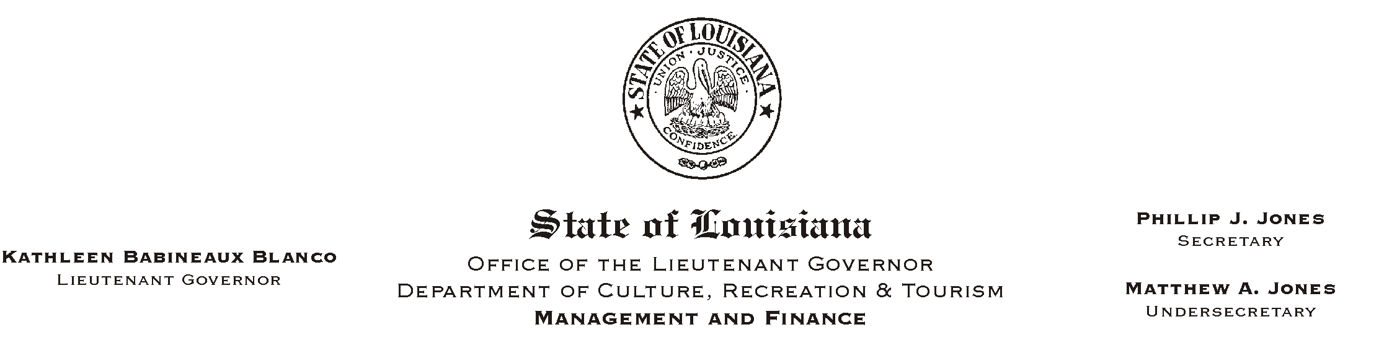
December 30, 2002
HUMAN RESOURCES MEMORANDUM NO. 02-110

TO: Lt. Governor, Secretary, Undersecretary, Assistant Secretaries, Deputy Assistant Secretaries, Program Managers

FROM: Mary F. Ginn
Human Resources Director

SUBJECT: Public Hearing Scheduled to Disclose Proposed Changes to Benefits
Please Post and Circulate

The Office of Group Benefits (OGB) is holding a public hearing to present proposed benefit changes for the 2003-2004 plan year and to receive comments from plan members and others. Following the OGB presentation of proposed changes, those attending may submit oral and/or written comments.

Public Hearing
Office of Group Benefits
Wednesday, January 8, 2003
6:00 - 7:30 p.m.

State Police Training Academy
7901 Independence Boulevard
Baton Rouge

If you are unable to attend this hearing, you may submit your comments via the OGB web site at www.groupbenefits.org or by mail to P. O. Box 44036, Baton Rouge, LA 70804.

