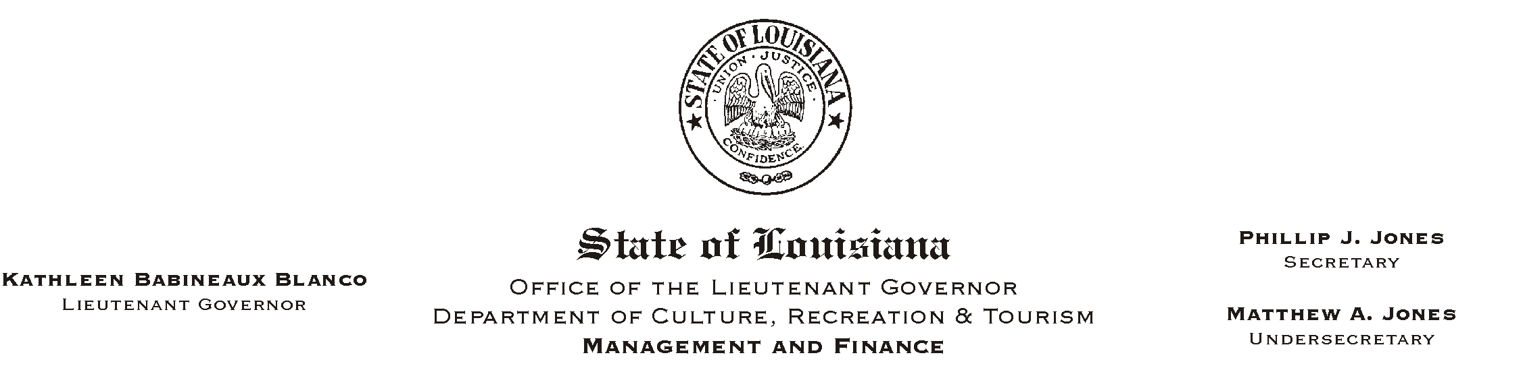
January 6, 2003
HUMAN RESOURCES MEMORANDUM NO. 03-001

TO: Lt. Governor, Secretary, Undersecretary, Assistant Secretaries, Deputy Assistant Secretaries, Program Managers

FROM: Mary F. Ginn
Human Resources Director

SUBJECT: Student Status Updates
Please Post and Circulate

This is a reminder that student employees are required to verify their full-time student status at the beginning of the spring and fall semesters in order to retain eligibility for State employment.

Please give each student in your department a copy of the attached student application with instructions to update the application and obtain school certification. Certified applications should be returned to the Human Resources Office no later than Friday, February 7, 2003.

If you have any questions, please call the Human Resources Office at (225) 342-0880.

Attachment

