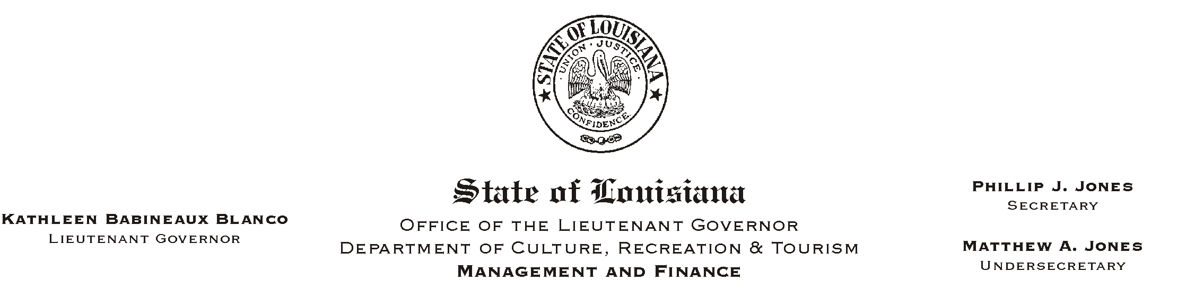
January 6, 2003
HUMAN RESOURCES MEMORANDUM NO. 03-002

TO: Lt. Governor, Secretary, Undersecretary, Assistant Secretaries, Deputy Assistant Secretaries, Program Managers

FROM: Mary F. Ginn
Human Resources Director

SUBJECT: W-2 Forms Processing for 2002
Please Post and Circulate

The Office of State Uniform Payroll (OSUP) is responsible for the processing and issuance of 2002 W-2 forms. Original forms will be mailed directly to each employee before the January 31, 2003 deadline. Agencies will not receive copies of the 2002 W-2 forms. OSUP will report 2002 W-2 information to the Internal Revenue Service through the Social Security Administration for all ISIS HR Paid Agencies and to the appropriate state revenue departments.

W-2 forms will be mailed to the same address that employee checks and/or earning statements are mailed. If your address has changed recently, it is imperative that you notify the Human Resources Office at (225) 342-0880 and complete the appropriate address change forms.

If you do not receive a W-2 form by January 31, 2003, please complete the attached form (Request for Duplicate) and return it to the Human Resources Office for processing.

Attachment

