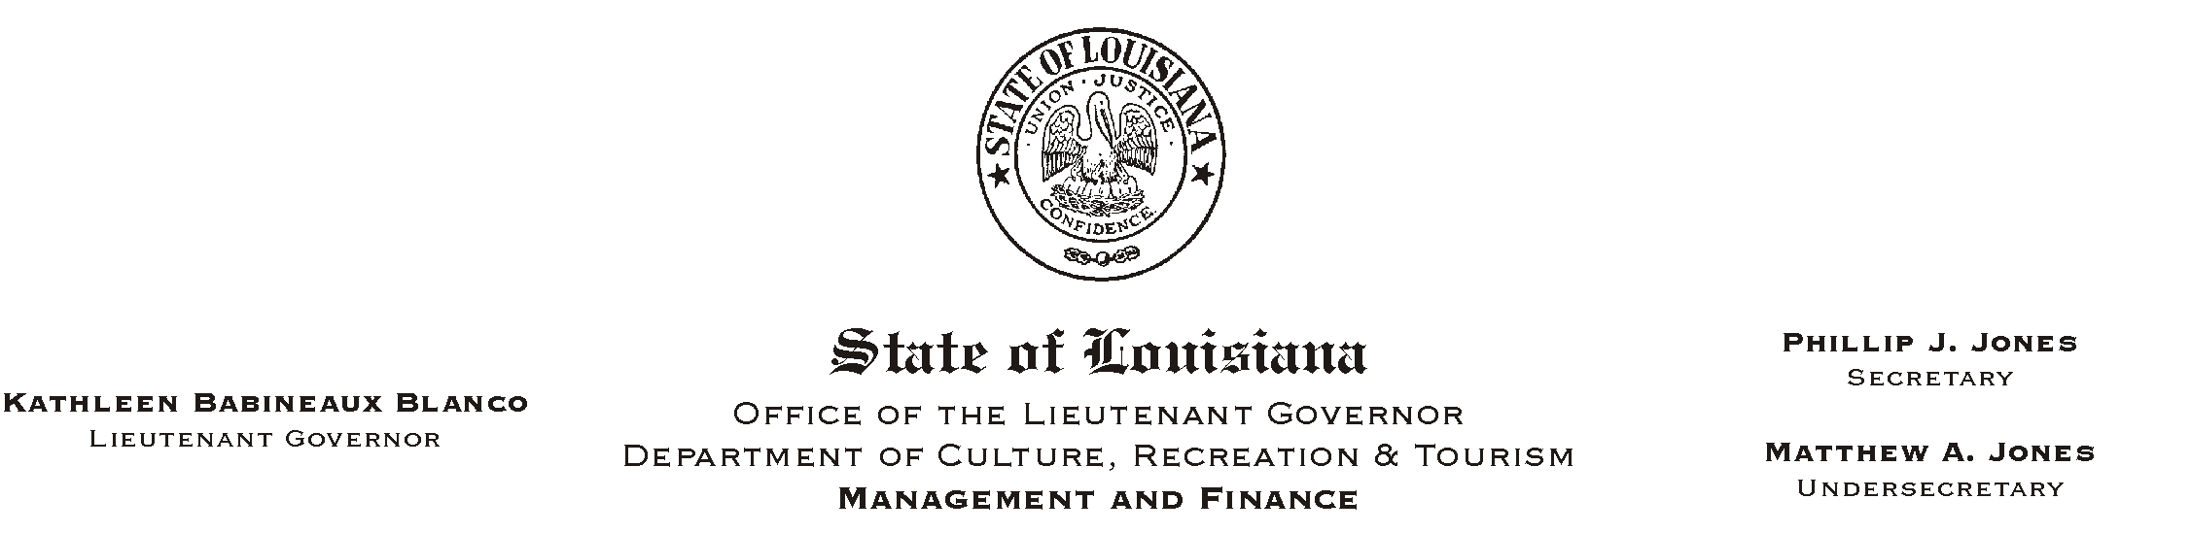
January 6, 2003
HUMAN RESOURCES MEMORANDUM NO. 03-004

TO: Lt. Governor, Secretary, Undersecretary, Assistant Secretaries, Deputy Assistant Secretaries, Program Managers

FROM: Mary F. Ginn
Human Resources Director

SUBJECT: 2003 W-4 Employee=s Withholding Form
Please Post and Circulate

Attached is an updated Federal W-4 tax withholding form for 2003. Employees are encouraged to review their current withholding status and use the new W-4 form if any changes are desired. If no changes are made, it is not necessary to complete a new form.

Employees who are currently claiming AExempt@ status must complete a new form to either affirm their exempt status or to change their status as appropriate.

Offices must begin immediately using the 2003 W-4 forms in their New Hire Orientation packages. The new hire checklist will be updated at a later date.

Please contact the Human Resources Office at (225) 342-0880 if you have any general questions about completing this form. Employees who need assistance in determining how much tax to withhold should contact the IRS or a tax consultant.

Attachment

