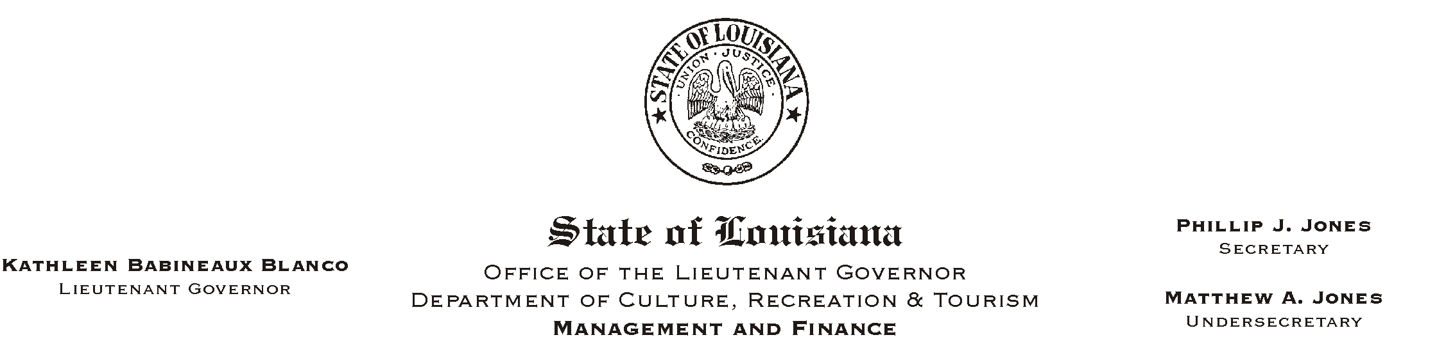
January 7, 2003
HUMAN RESOURCES MEMORANDUM NO. 03-007

TO: Lt. Governor, Secretary, Undersecretary, Assistant Secretaries, Deputy Assistant Secretaries, Program Managers

FROM: Mary F. Ginn
Human Resources Director

SUBJECT: Implementation Delay of 2003 Revised Tax Tables
Please Post and Circulate

We notified you by HR Memorandum No. 03-003 that the new Federal Tax Tables were effective January 1, 2003 and new deductions would appear on the January 10, 2003 checks/earnings statements. We have just learned, however, that there will be a delay in the implementation of both the new Federal and State tax tables due to several technical problems within the Office of State Uniform Payroll (OSUP).

OSUP has advised us that once the new tax tables (both Federal and State) are loaded into the payroll system, employees will be notified by messages on their checks/earning statements. If corrective action is needed because of these delays, employees will be notified.

If you have any questions, please call the Human Resources Office at (225) 342-0880.

