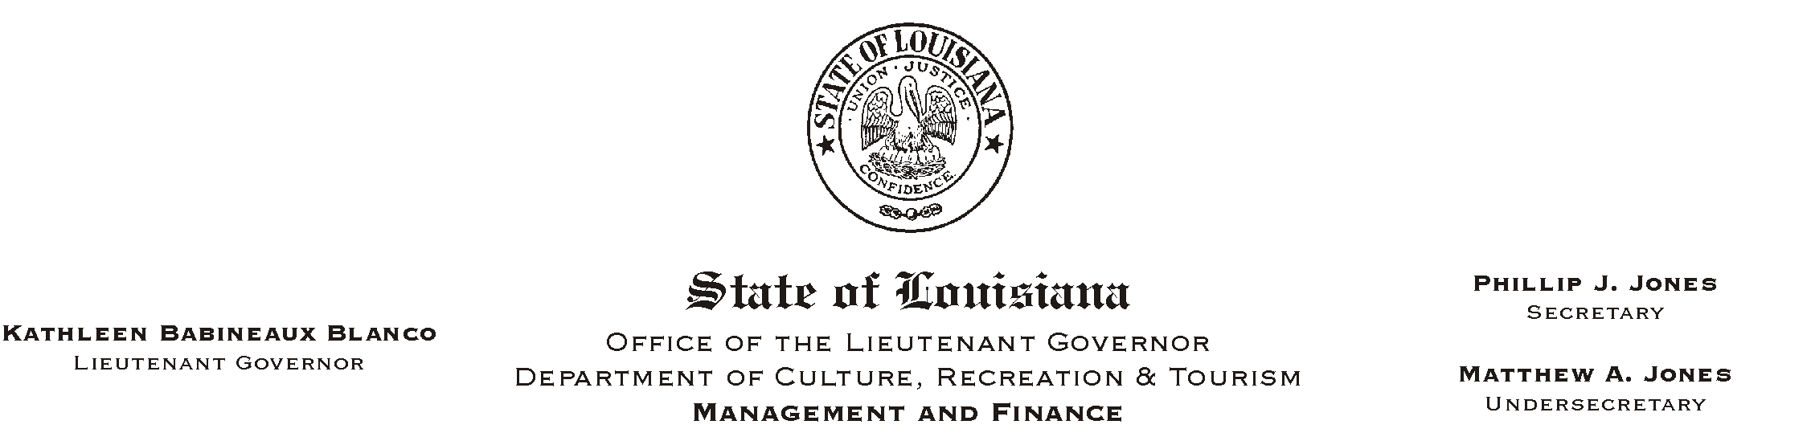
HUMAN RESOURCES MEMORANDUM NO. 03-008

January 13, 2003

TO: Lt. Governor, Secretary, Undersecretary, Assistant Secretaries, Deputy Assistant Secretaries, Program Managers

FROM: Mary F. Ginn
Human Resources Director

SUBJECT: Annual Performance Planning and Review Report for Fiscal Year 2001-2002

Enclosed is the Annual Performance Planning and Review Report for Fiscal Year 2001-2002 compiled by the Department of State Civil Service. This is a statewide compilation of un-Rated rates for PPR's. This report also includes reasons for the decline in un-rated PPR's statewide.

Each state department is required to submit a report at the end of the fiscal year to Civil Service with the percentage of each rating: outstanding, exceeds requirements, meets requirements, needs improvement, poor and un-rated. The goal of each department is to achieve an un-rated percentage of zero. We are proud to say that our department's un-rated percent for the 2001-2002 fiscal year was 2.1%. Congratulations to all of you for your hard work!

Enclosure

Please Post and Circulate

