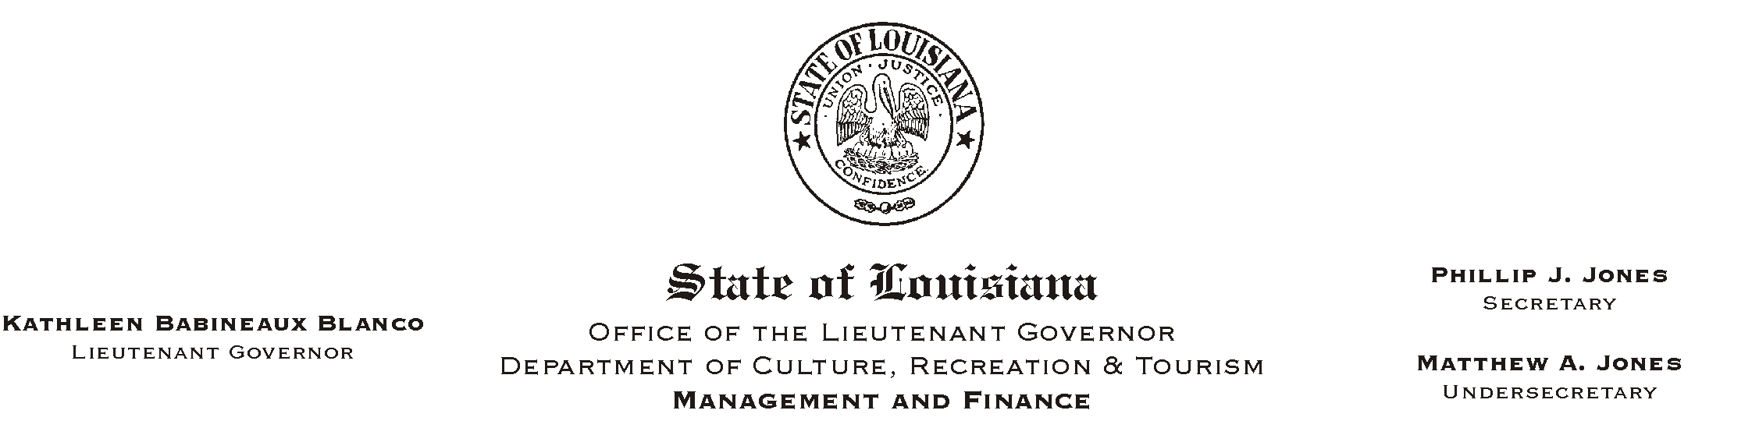
January 14, 2003
HUMAN RESOURCES MEMORANDUM NO. 03-012

TO: Lt. Governor, Secretary, Undersecretary, Assistant Secretaries, Deputy Assistant Secretaries, Program Managers

FROM: Mary F. Ginn
Human Resources Director

SUBJECT: Operation of a State Vehicle
Please Post and Circulate

Employees who are authorized to drive a state vehicle must comply with the requirements set forth by this department and the Office of Risk Management (ORM). The following is a checklist of items to remember:

- Only employees authorized by their agency head or designee are allowed to operate state vehicles. Employees must maintain a valid driver=s license.

- Always do a visual safety inspection of the vehicle before beginning operation.

- Complete the log sheet contained in the vehicle and record the destination, fuel consumption, and miles traveled.

- Make sure the vehicle contains the Vehicle Accident Report DA-2041. This form must be completed in case of an accident and submitted to the ORM Claims Department within 48 hours of the accident.

- Never allow a stranger or non-employee to ride in a state vehicle per ORM PPM-49; only authorized employees are allowed to ride in a state vehicle. Non-employees are only allowed to ride in a state vehicle with proper authorization on a case by case basis from the Appointing Authority of each agency.

- Never use a state vehicle to take care of personal business. State vehicles may only be used to conduct official state business.

If you have any questions, please contact Gerald Ganey, Safety Director, at (225) 219-9413.

