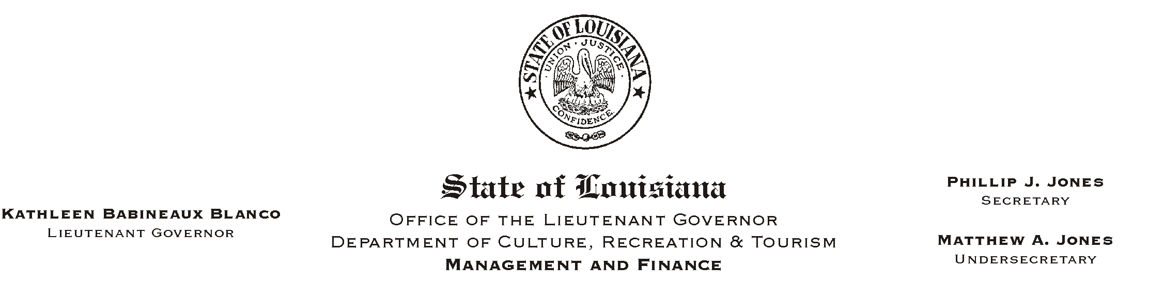
January 28, 2003
HUMAN RESOURCES MEMORANDUM NO. 03-017

TO: Lt. Governor, Secretary, Undersecretary, Assistant Secretaries, Deputy Assistant Secretaries, Program Managers

FROM: Mary F. Ginn
Human Resources Director

SUBJECT: Workplace Harassment/Discrimination Policy Acknowledgments
Please Post and Circulate
Action Required By February 7, 2003

In September, 2002, the revised AWorkplace Harassment/Discrimination@ policy was issued by Human Resources Memorandum No. 02-081 (attached) and managers were advised to make copies of the policy and distribute to all employees. Signed policy acknowledgments were due October 4, 2002. To date, many offices have not complied with this directive.

The attached report lists the employees who have not acknowledged this policy. If necessary, copy and redistribute the policy to those employees listed and forward the acknowledgments to the Human Resources Office no later than February 7, 2003.

If you have any questions, call the Human Resources Office at (225) 342-0880.

Attachments

