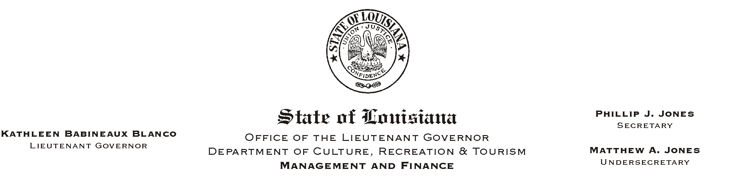
January 28, 2003
HUMAN RESOURCES MEMORANDUM NO. 03-018

TO: Lt. Governor, Secretary, Undersecretary, Assistant Secretaries, Deputy Assistant Secretaries, Program Managers

FROM: Mary F. Ginn
Human Resources Director

SUBJECT: Training Series Consideration Form
Please Post and Circulate

The attached form is to be used when requesting an employee=s reallocation to the next level within a training series. An employee=s advancement within a training series is not automatic. It is based upon the supervisor=s certification that the employee has met all the requirements to progress to the next level. Appointing Authority approval is also required.

We are evaluating all training series positions to establish date ticklers within the ISIS HR system. Once this project is completed, we will begin sending reminders to supervisors of employees who are eligible for advancement within a training series. Until the tickler system is completed, we will continue to depend on supervisors notifying our office of the employees who are eligible and approved for advancement within their training series.

If you have any questions, please contact the Human Resources Office at (225) 342-0880.

Attachment

