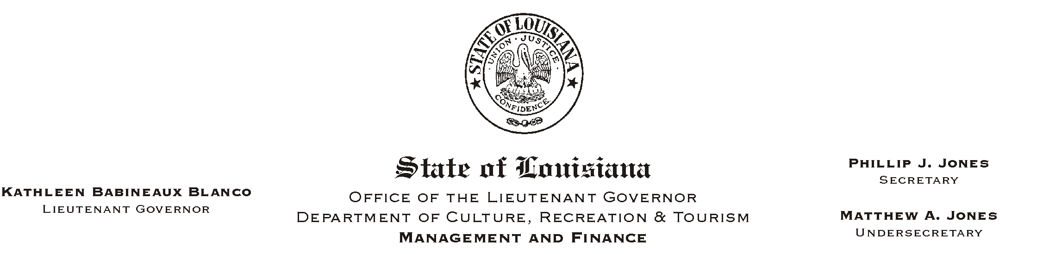
HUMAN RESOURCES MEMORANDUM NO. 03-019

February 3, 2003

TO: Lt. Governor, Secretary, Undersecretary, Assistant Secretaries, Deputy Assistant Secretaries, Program Managers

FROM: Mary F. Ginn
Human Resources Director

SUBJECT: Drug Testing Policy Update

Recently, we requested your input regarding safety-sensitive and other positions that should be added to the random testing pool. The drug testing policy has been revised to include the addition of other designated positions. The concept for random testing has been expanded to include "safety-sensitive and designated positions".

On Page 2, the second paragraph of Section II has been changed to read:

"Following a job offer, potential employees and potential appointees will be required to submit to pre-employment drug testing. All employees are subject to post-accident/ incident, reasonable suspicion and return-to-duty/rehabilitation monitoring drug and alcohol testing. Employees who incumber safety-sensitive and other such designated positions and applicants who apply for such positions are subject to both random and pre-selection drug and alcohol testing. Finally, prior to being reassigned, temporarily detailed, promoted or demoted to a safety-sensitive or other such designated position, an employee is required to undergo drug and alcohol testing. A list of these positions within this Department is attached as Appendix A."

On Page 7, Number 9 of Section V, "Drug Testing Procedures," and Number 3 of Section VI, "Alcohol Testing Procedures," both had terminology changes. The term "safety-sensitive functions" was replaced with "his/her customary duties."

Appendix A has also been revised to include the job titles that have been added to the random testing pool.

Effective February 1, 2003, Secon will no longer hold the drug-testing contract for the state. One Source Toxicology is the new contractor. We must begin immediately using the new Chain of Custody form. Please discard all of the old forms marked Kroll Laboratory Specialists.

HR Memo # 03-019
February 3, 2003
Page 2

The new Chain of Custody form is very similar to the previous form. The donor will complete only the top line of Step 2 and check the top line of Step 3 indicating the "Reason for Test".

Also, a new collection site list is enclosed. Many of the collection sites have changed. You must send donors to test at one of these sites. We are working with One Source Toxicology to add more sites to the list, specifically in Natchitoches, Sabine, East Carroll and West Carroll Parishes. If you have a need for an additional testing site that is not on the new list or in one of the above-mentioned parishes, please let us know.

Please contact the Human Resources Office at (225) 342-0880 for further information or clarification.

Enclosures

Please Post and Circulate

