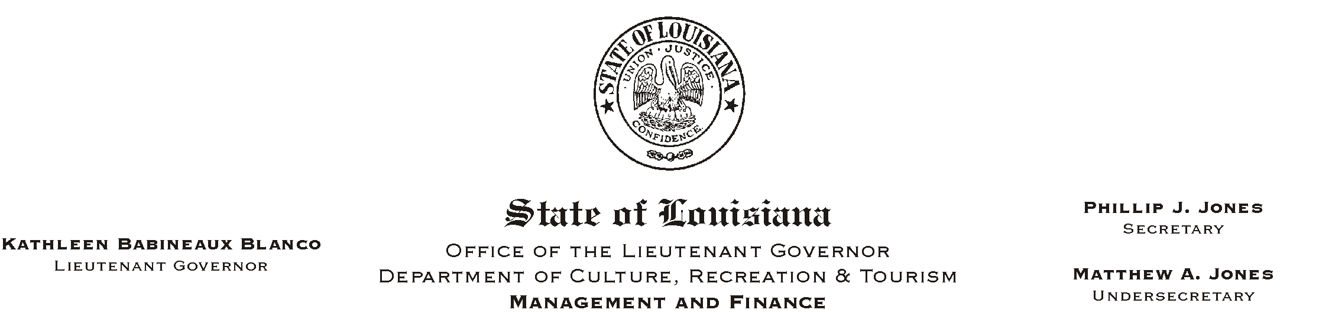
February 13, 2003
HUMAN RESOURCES MEMORANDUM NO. 03-024

TO: Lt. Governor, Secretary, Undersecretary, Assistant Secretaries, Deputy Assistant Secretaries, Program Managers

FROM: Mary F. Ginn
Human Resources Director

SUBJECT: Military Reservists
Please Post and Circulate

Due to the military crisis facing our nation and the probability that some of our employees may be called to active service, we would like to update the information we provided last year in HR Memo No. 02-008 (attached).

Attached for your information and use are:

- Updated Civil Service Rules regarding Military Leave
- LASERS Liaison Memorandum No. 01-19 RE: Military Leave
- Office of Group Benefits Executive Policy 01-01 - Military Duty
- Military Reserve Option Form

Civil Service is not planning to publish a General Circular with references to the updated rules, so General Circular No. 001458 sent last year is not included with this memo. We have verified with Group Benefits and LASERS that the information presented last year is still current.

We understand that call-up can often happen quickly and the employees may not have an opportunity to make certain employment or benefits decisions in advance. If this occurs, please mail the Military Reserve Option Form to them so that we know how to handle their benefits.

Please encourage your employees who are military reservists to contact the Human Resources Office if they have any questions concerning their entitlements and/or the options available to them.

Attachments

