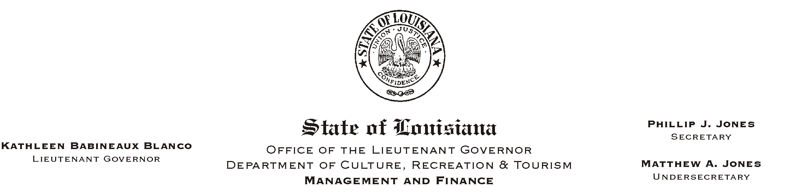

HUMAN RESOURCES MEMORANDUM NO. 03-028

March 19, 2003

TO: Lt. Governor, Secretary, Undersecretary, Assistant Secretaries, Deputy Assistant Secretaries, Program Managers

FROM: Mary F. Ginn
Human Resources Director

SUBJECT: Governmental Ethics Seminar

A seminar on Governmental Ethics will be presented for all employees by Peggy Sabadie an Attorney with the Louisiana Board of Ethics Administration. Details are as follows:

Governmental Ethics Seminar
April 16, 2003, 1:00 p.m.
State Library's Seminar Center

Please RSVP by e-mail to mginn@crt.state.la.us.

Please Post and Circulate

