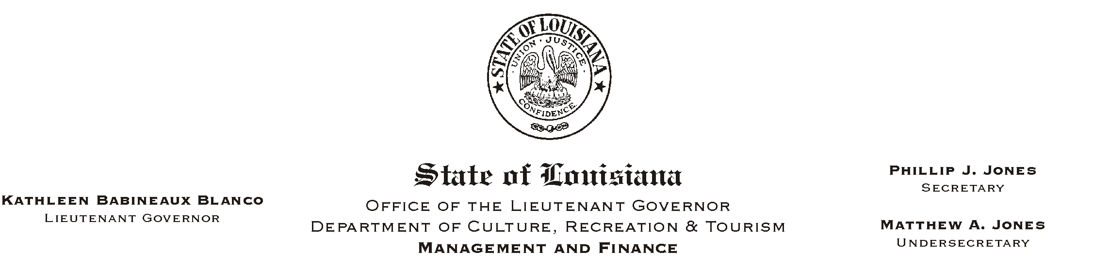

HUMAN RESOURCES MEMORANDUM NO. 03-033

March 26, 2003

TO: Lt. Governor, Secretary, Undersecretary and Assistant Secretaries

FROM: Mary F. Ginn
Human Resources Director

SUBJECT: Clerical Association of Louisiana – Annual Educational Conference

The Clerical Association of Louisiana will hold its annual Educational Conference October 8-10, 2003, at the LeBossier Hotel and Conference Center in Bossier City, Louisiana. A tentative agenda and registration forms are attached.

Please review this information and if your budget permits, notify your clerical employees of this opportunity. If you have any questions about the conference, call Judy K. Mason, President of the Clerical Association at (318) 368-7917.

Attachments

Please Post and Circulate

