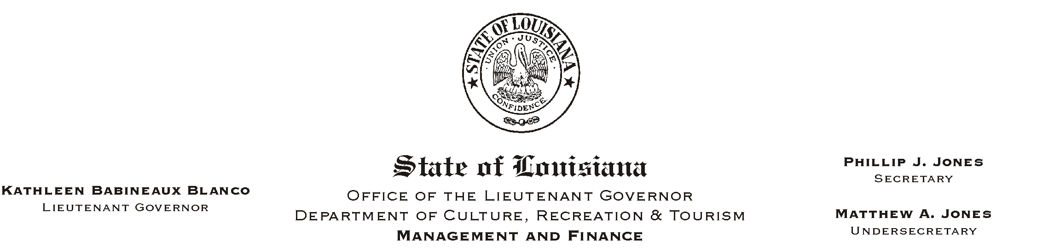

HUMAN RESOURCES MEMORANDUM NO. 03-034

March 26, 2003

TO: Lt. Governor, Secretary, Undersecretary, Assistant Secretaries, Deputy Assistant Secretaries, Program Managers

FROM: Mary F. Ginn
Human Resources Director

SUBJECT: Updated Guide to Employee Assistance Program

The state’s Employee Assistance Program (EAP) is designed to assist and support employees who are experiencing personal problems and who may benefit from outside management or professional help. These problems include substance abuse, family, emotional, financial, and other problems that affect job performance, job security, or the health and well being of the employees.

Please place copies of this brochure in locations convenient to all employees and discard outdated versions. Those offices authorized to conduct new hire orientation should also update their orientation packets with this revision.

Although this brochure is primarily for the Baton Rouge area, the information it contains is applicable for all employees throughout the state. Employees outside of the Baton Rouge area may call during business hours any of the committee members listed in the brochure to obtain the name of a contact near their location. For critical problems requiring attention after hours or on weekends, confidential counseling services are available from THE PHONE. In Baton Rouge, the number is (225) 924-3900. Other cities in Louisiana have similar services available and it is recommended that each office obtain the local numbers and make them available to employees.

If you have any questions about the EAP or need assistance in any way, please call the Human Resources Office at (225) 342-0880.

Attachment

Please Post and Circulate

