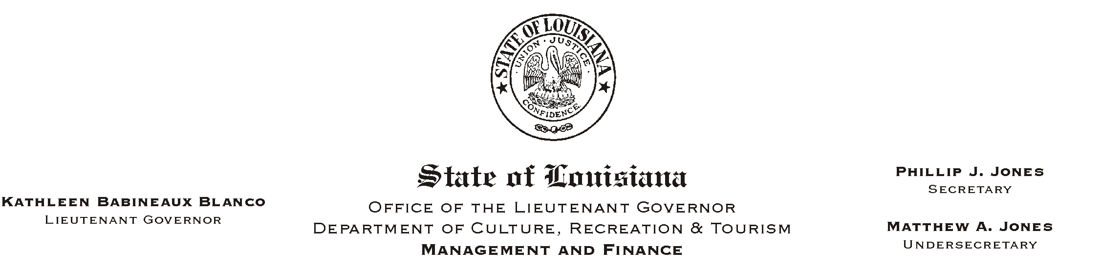

HUMAN RESOURCES MEMORANDUM NO. 03-037

March 31, 2003

TO: Lt. Governor, Secretary, Undersecretary, Assistant Secretaries, Deputy Assistant Secretaries, Program Managers

FROM: Mary F. Ginn
Human Resources Director

SUBJECT: PET Training Class

A Professional Entry Test (PET) Training Class will be conducted on April 24, 2003, in the State Library Seminar Center. The training will begin at 8:30 a.m. and conclude at approximately 3:00 p.m., depending on the size of the class.

Managers should encourage their employees, who qualify for professional level jobs and are interested in promotional opportunities, to attend this training class to prepare for the Professional Entry Test.

Please register for the class by completing the attached form and returning it to the Human Resources Office by mail or fax to (225) 342-7928. Please call (225) 342-0880 if you have any questions.

Attachment

Please Post and Circulate

