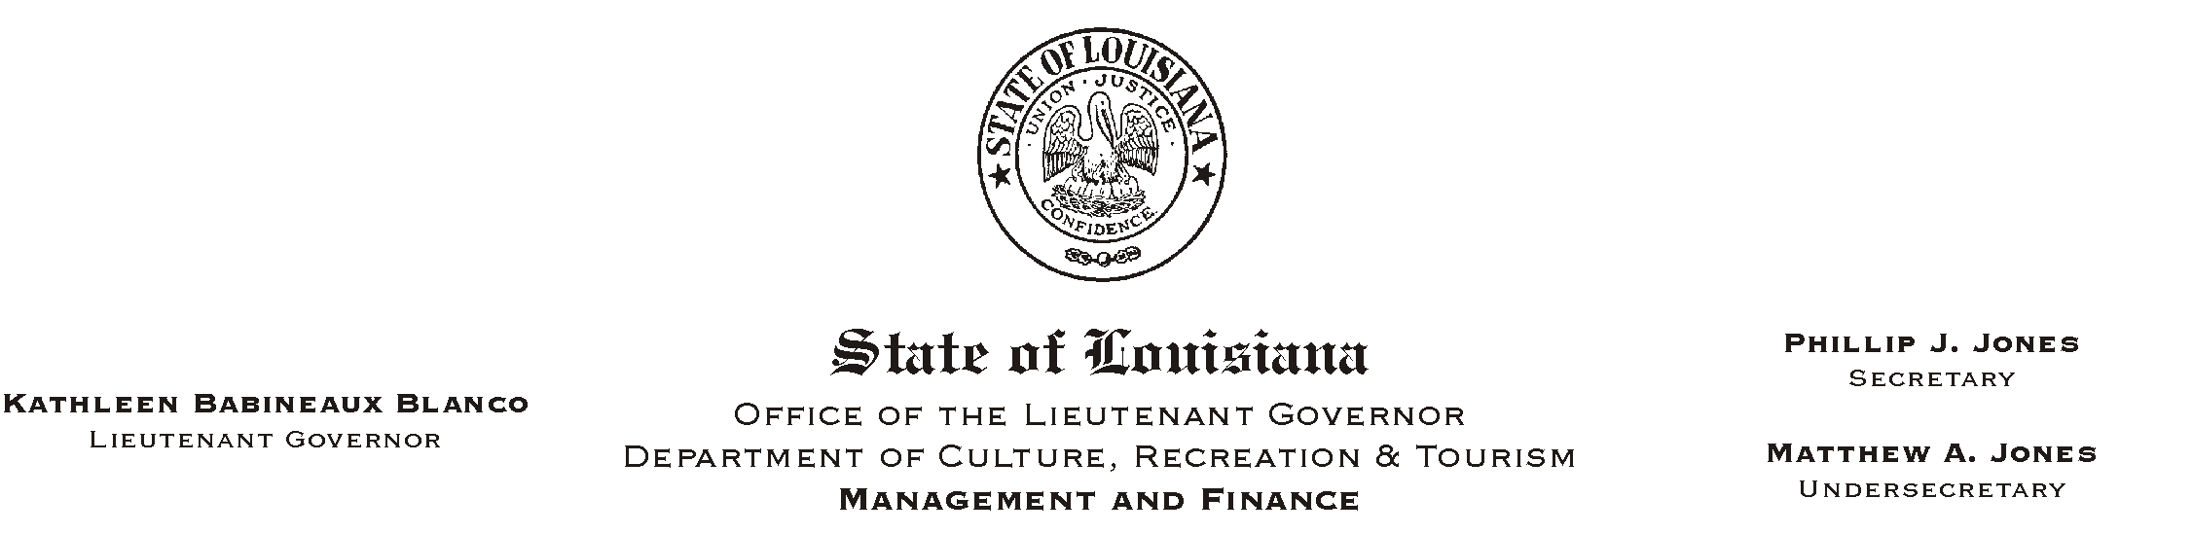

HUMAN RESOURCES MEMORANDUM NO. 03-038

March 31, 2003

TO: Lt. Governor, Secretary, Undersecretary, Assistant Secretaries, Deputy Assistant Secretaries, Program Managers

FROM: Mary F. Ginn
Human Resources Director

SUBJECT: Guidelines for Timekeepers

On March 6, 2003, we conducted a timekeeping workshop in Baton Rouge for CRT’s official timekeepers (those who have the security clearance to enter time into the ISIS HR/Payroll system). It was a very productive meeting with an excellent exchange of information among participants.

A set of guidelines was developed for this training and the participants were asked for input. As a result of input received, a few revisions were made and the final document is attached. We feel that this information will be beneficial for anyone who participates in the timekeeping process, including managers, supervisors, and clerks.

Please provide this information to anyone who approves leave, codes timesheets, enters time into the ISIS system, or audits time entry reports. If you have any questions or if you would like us to conduct further training for other employees involved in the timekeeping process, please contact Kathleen Miller at (225) 219-9453.

Attachment

Please Post and Circulate

