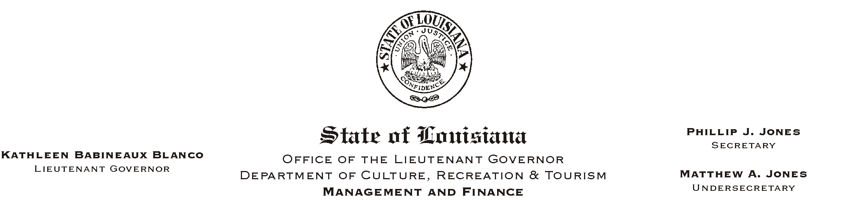

HUMAN RESOURCES MEMORANDUM NO. 03-044

April 14, 2003

TO: Lt. Governor, Secretary, Undersecretary, Assistant Secretaries, Deputy Assistant Secretaries, Program Managers

FROM: Mary F. Ginn
Human Resources Director

SUBJECT: A Lunch & Learn Workshop
(Another in our series of informational meetings on health, safety, & well being.)

“Work at Respect™”
Michael C. Garrard, Attorney
Friday, April 25, 2003, 11:30 a.m. – 1:00 p.m.

Seminar Center, State Library

©2002, Work At Respect™LLC
ALL RIGHTS RESERVED

Work at Respect is also a trademark

owned by Work At Respect™LLC

You are invited to attend a Lunch & Learn Workshop presented by Michael Garrard, Attorney, and adjunct professor of labor law at LSU. Mr. Garrard’s presentation will cover the practices and habits which allow all to be successful in the modern workplace, while at the same time avoiding claims of harassment and discrimination.

Our lunch and learn programs are generally designed to present information to employees on achieving health, safety, and well being. This program is designed to help all employees learn the benefits of practicing respect in the workplace. When employees feel respected, they also feel a sense of well being which can lead to success at work and daily living.

Please complete the attached registration form and submit it to the Human Resources Office or register on-line on “Channel Z” no later than 12:00 noon on Thursday, April 24, 2003. Employees can order lunch from Mortorano’s Italian Deli or bring their own lunch. You must provide your own soft drink. We encourage you, if possible, to pay by check. Cancellations must be phoned in to us at (225) 342-0880 before the deadline or they will be considered a guarantee of payment.

Attachment

PLEASE POST AND CIRCULATE

A “LUNCH AND LEARN” WORKSHOP

“Work at Respect™”
Michael C. Garrard, Attorney
Friday, April 25, 2003, 11:30 a.m. – 1:00 p.m.

Seminar Center, State Library

©2002, Work At Respect™LLC
ALL RIGHTS RESERVED

Work at Respect is also a trademark

owned by Work At Respect™LLC

REGISTRATION FORM
Please Print
Name_________________________________________________________________________

Department________________________________________ Phone #____________________

____ Include me in the Box Lunch

IMPORTANT: If you are unable to attend after making a reservation and fail to notify us, please understand that we must consider this registration a guarantee for your payment.

Lunch Choices from Mortorano’s Italian Deli: Prices include 9% tax

____ Chicken Parmigiano (with pasta & garlic bread) - $7.03
____ Meatballs & Spaghetti (with garlic bread) - $6.92
____ Eggplant Parmigiano Sandwich – $6.49
____ Muffaletto (Half) - $6.81
____ Grilled Chicken Sensation Salad - $7.09

Payment Choice:

____ Check for the lunch amount payable to Mortorano’s Italian Deli is attached
____ I will pay at the meeting (please pay by check)

OR
____ I will attend the presentation but will not participate in the lunch.

Signatures:

EMPLOYEE__________________________________________ Date______________

SUPERVISOR_________________________________________ Date______________

