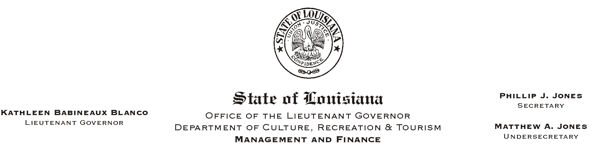

HUMAN RESOURCES MEMORANDUM NO. 03-047

April 28, 2003

TO: Lt. Governor, Secretary, Undersecretary, Assistant Secretaries, Deputy Assistant Secretaries, Program Managers

FROM: Mary F. Ginn
Human Resources Director

SUBJECT: State Employee Recognition Reception

Governor Mike Foster has proclaimed May 7, 2003 State Employee Recognition Day as a part of the nationwide Public Service Recognition Week which is the week of May 5, 2003 until May 9, 2003. This week and day were established to make the public aware of the services that public employees provide. The week has also been established to recognize and thank employees who dedicate themselves to public service and the hard work and effort they put forth to serve the needs of citizens. We have attached a copy of the Governor’s Proclamation for your review.

Lieutenant Governor Kathleen Blanco and Secretary Phillip Jones will host an Employee Recognition Reception to thank all employees for their hard work and dedication to the department and to the State of the Louisiana. The reception will be held on Friday, May 9, 2003 at 2:30 p.m. in the State Library Seminar Center in Baton Rouge.

If you can attend, please RSVP by calling the Human Resources Office at (225) 342-0880 or e-mailing Heather Sherlock at hsherlock@crt.state.la.us.

Attachment

Please Post and Circulate

Please Post and Circulate

