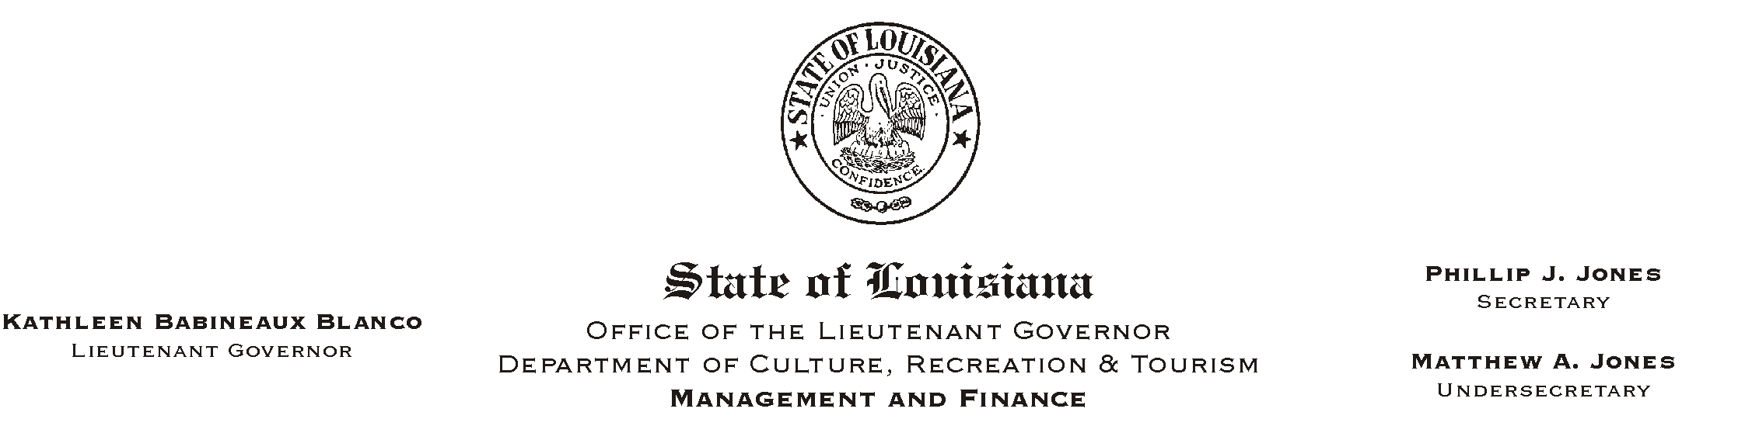

HUMAN RESOURCES MEMORANDUM NO. 03-050

May 6, 2003

TO: Lt. Governor, Secretary, Undersecretary, Assistant Secretaries, Deputy Assistant Secretaries, Program Managers

FROM: Mary F. Ginn
Human Resources Director

SUBJECT: A Lunch & Learn Workshop
(Another in our series of informational meetings on health, safety, & well being.)

“Louisiana Library Connection (Databases)”

Margaret Harrison, Reference Librarian, State Library of Louisiana
Thursday, May 22, 2003, 11:30 a.m. – 1:00 p.m.

Seminar Center, State Library

You are invited to attend a Lunch & Learn Workshop presented by Margaret Harrison, Reference Librarian for the State Library. Ms. Harrison will present information on the State Library’s online databases available free of charge to state employees who are also library patrons. Today, the State Library does more for state employees and officials than simply lending books and providing reference materials. Extensive resources that were once available only in print are now available online. Using this database system, employees can:

- Track down ancestors
- Access encyclopedias and reference materials
- Evaluate consumer products
- Learn more about medical conditions and prescription drugs
- Research historical events and documents
- Locate a company, its subsidiaries and its website
- Search newspapers and magazines, both current issues and archives
- Practice taking standardized exams
- Find literary essays and criticism
- Gather biographical information about famous people, past and present

Don’t miss this opportunity. Please complete the attached registration form and submit it to the Human Resources Office or register on-line on “Channel Z” no later than 12:00 noon on Wednesday, May 21, 2003. Employees can order lunch from Mortorano’s Italian Deli or bring their own lunch. You must provide your own soft drink. We encourage you, if possible, to pay by check. Cancellations must be phoned in to us at (225) 342-0880 before the deadline or the reservation will be considered a guarantee of payment.

Attachment

PLEASE POST AND CIRCULATE

A “LUNCH AND LEARN” WORKSHOP

“Louisiana Library Connection (Databases)”

Margaret Harrison, Reference Librarian, State Library of Louisiana
Thursday, May 22, 2003, 11:30 a.m. – 1:00 p.m.

Seminar Center, State Library

REGISTRATION FORM

Please Print
Name_________________________________________________________________________

Department________________________________________ Phone #____________________

____ Include me in the Box Lunch

IMPORTANT: If you are unable to attend after making a reservation and fail to notify us, please understand that we must consider this registration a guarantee for your payment.

Lunch Choices from Mortorano’s Italian Deli: Prices include 9% tax

____ Chicken Parmigiano (with pasta & garlic bread) - $7.03
____ Meatballs & Spaghetti (with garlic bread) - $6.92
____ Eggplant Parmigiano Sandwich – $6.49
____ Muffaletto (Half) - $6.81
____ Grilled Chicken Sensation Salad - $7.09

Payment Choice:

____ Check for the lunch amount payable to Mortorano’s Italian Deli is attached.
____ I will pay at the meeting (please pay by check).

OR
____ I will attend the presentation but will not participate in the lunch.

Signatures:

EMPLOYEE__________________________________________ Date______________

SUPERVISOR____________________________________________ Date______________

