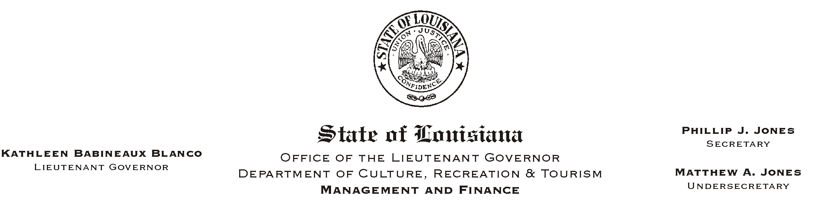

HUMAN RESOURCES MEMORANDUM NO. 03-052

May 12, 2003

TO: Lt. Governor, Secretary, Undersecretary, Assistant Secretaries, Deputy Assistant Secretaries, Program Managers

FROM: Mary F. Ginn
Human Resources Director

SUBJECT: Revised New Hire Orientation Checklist and Acknowledgment Form,
Plus Two New Employment Tools for the New Hire Packages

The New Hire Orientation Checklist and Employee Policy Acknowledgment Form have been revised and are enclosed. Please destroy any copies you may have of these forms and begin immediately to use the updated versions.

Please note that among updated revision dates, several new items have been added. A new section for Pre-Employment Requirements has been added to the beginning of the checklist as a reminder of the things that must be completed prior to hiring an employee.

The “State Employment: Advantages and Responsibilities” video that was previously released has been added as the first item under “Welcome, Introduction to Orientation, and Employment Forms.” Also added as a reminder is the “Applicant Recapitulation Report” (of Civil Service Certificate).

Check all of the policies you are currently using against the revision dates on the checklist to be sure you are using current documents.

Several new items have been added under Benefits. General information includes a document titled “Some of the Benefits of Working in Louisiana State Government” recently issued by HR Memo #03-049. This document is also included with this mail-out. A new list of benefits providers’ web sites and customer service numbers is also attached for you to add to your benefits information.

It is very important for us to know whether a new employee is retired from one of the state retirement systems or is a current member of another retirement system. Therefore, those questions have been added under Retirement.

Finally, the insurance section has been revised to include the current selection of providers. If you have any questions, please call the Human Resources Office at (225) 342-0880.

Attachments

Please Post and Circulate

