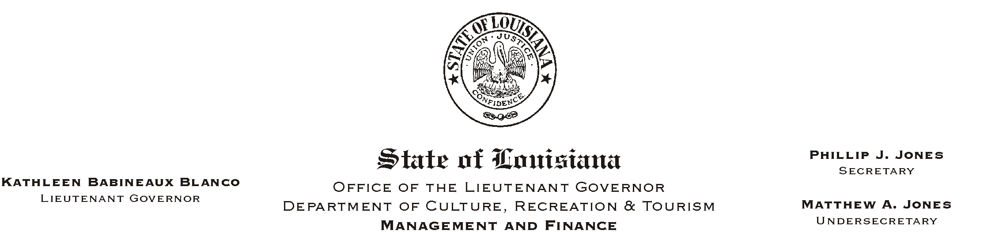

HUMAN RESOURCES MEMORANDUM NO. 03-053

May 12, 2003

TO: Lt. Governor, Secretary, Undersecretary, Assistant Secretaries, Deputy Assistant Secretaries, Program Managers

FROM: Mary F. Ginn
Human Resources Director

SUBJECT: Memorial Day Holiday/Payroll Deadline

Governor Foster has proclaimed Monday, May 26, 2003, a legal holiday for State workers in observance of National Memorial Day (see attached).

Because of this holiday, all payroll information for the pay period ending May 25, 2003, must be received in the Human Resources Office no later than Wednesday, May 21, 2003. This deadline also applies to employees who need to update their payroll or benefits information (i.e., direct deposit authorizations, insurance, address, etc.) during this pay period.

If you have any questions, please call the Human Resources Office at (225) 342-0880.

Attachment

Please Post and Circulate

