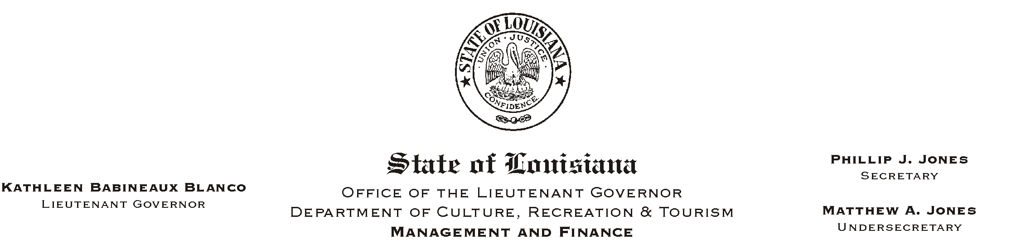

HUMAN RESOURCES MEMORANDUM NO. 03-057

May 22, 2003

TO: Lt. Governor, Secretary, Undersecretary, Assistant Secretaries, Deputy Assistant Secretaries, Program Managers

FROM: Mary F. Ginn
Human Resources Director

SUBJECT: A Lunch & Learn Workshop
(Another in our series of informational meetings on health, safety, & well being.)

“Life and Career Management: A Balance of Power”

Nicholas Abraham, M.Div., Ph.D.
Wednesday, June 18, 2003, 11:30 a.m. – 1:00 p.m.

Seminar Center, State Library

You are invited to attend a Lunch & Learn Workshop presented by Nicholas Abraham, M.Div., Ph.D., on “Life and Career Management: A Balance of Power,” which is the title of his upcoming new book. Dr. Abraham is an executive coach, educator, speaker, and musician. He is president of The Abraham Group, a marketing, training, and consulting firm. Because of his talents, Dr. Abraham has the ability to connect with a variety of audiences across the country. He is noted for his contagious spirit, humor, and current perspectives.

Dr. Abraham’s focus, as the title suggests, is on attaining balance in your life. We all face the challenge of striving for balance in our lives. For many, the struggle is ongoing. For others, it comes in cycles. Perhaps the demands of your work are leaving very little time for anything else. Perhaps the demands of family or outside activities are making it difficult to concentrate on your work or even get to work. Whatever challenges you face, Dr. Abraham’s presentation will energize you with ideas for achieving balance and peace of mind. For a sneak preview, visit Dr. Abraham’s web site at www.abrahamgroup.com.

Don’t miss this opportunity. Please complete the attached registration form and submit it to the Human Resources Office or register on-line on “Channel Z” no later than 12:00 noon on Tuesday, June 17, 2003. Employees can order lunch from Mortorano’s Italian Deli or bring their own lunch. You must provide your own soft drink. We encourage you, if possible, to pay by check. Cancellations must be phoned in to us at (225) 342-0880 before the deadline, or the reservation will be considered a guarantee of payment.

Attachment
A “LUNCH AND LEARN” WORKSHOP

Please Post and Circulate

“Life and Career Management: A Balance of Power”

Nicholas Abraham, M.Div., Ph.D.
Wednesday, June 18, 2003, 11:30 a.m. – 1:00 p.m.

Seminar Center, State Library

REGISTRATION FORM

Please Print
Name_________________________________________________________________________

Department________________________________________ Phone #____________________

____ Include me in the Box Lunch

IMPORTANT: If you are unable to attend after making a reservation and fail to notify us, please understand that we must consider this registration a guarantee for your payment.

Lunch Choices from Mortorano’s Italian Deli: Prices include 9% tax

____ Chicken Parmigiano (with pasta & garlic bread) - $7.03
____ Meatballs & Spaghetti (with garlic bread) - $6.92
____ Eggplant Parmigiano Sandwich – $6.49
____ Muffaletto (Half) - $6.81
____ Grilled Chicken Sensation Salad - $7.09

Payment Choice:

____ Check for the lunch amount payable to Mortorano’s Italian Deli is attached.
____ I will pay at the meeting (please pay by check).

OR
____ I will attend the presentation but will not participate in the lunch.

Signatures:

EMPLOYEE__________________________________________ Date______________

SUPERVISOR________________________________________ Date______________

