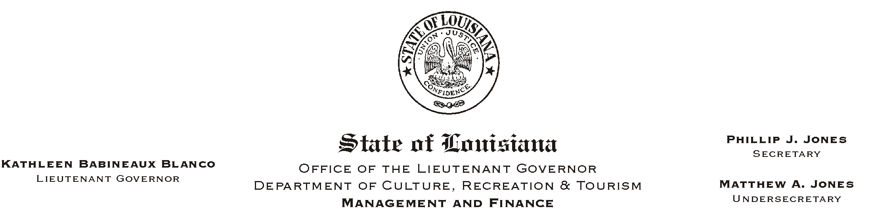

HUMAN RESOURCES MEMORANDUM NO. 03-058

June 10, 2003

TO: Lt. Governor, Secretary, Undersecretary, Assistant Secretaries, Deputy Assistant Secretaries, Program Managers, and All Employees

FROM: Mary F. Ginn
Human Resources Director

SUBJECT: Insurance Updates – Changes Appearing on Pay Stubs

A number of changes occurred this year during Annual Enrollment. If you attended enrollment meetings and stayed abreast of the information we distributed, you are aware of the changes in insurance options and rates. Now that Annual Enrollment is over, other changes are occurring that affect the way we will process insurance enrollments and changes in the future, beginning July 1, 2003.

The Office of Group Benefits (OGB) has implemented the new eEnrollment system requiring agencies (and employees, in the future) to enter the enrollments and changes that were once entered by OGB staff. OGB, however, has entered the changes for this annual enrollment and Human Resources will assume those duties for actions effective July 1, 2003 and beyond. The insurance data entered into the OGB eEnrollment system was recently interfaced with the ISIS Payroll system, and the deductions will now appear differently on your pay stub.

Beginning Friday, June 13, 2003, the new insurance deduction rates and different terminology will appear on pay stubs. (Note: Premiums for the new July 1, 2003 plan-year begin in June) Pay stubs will no longer identify insurance carriers by specific name. Instead, a generic term will identify that you have health or life insurance and whether you are in the Flexible Benefits Plan (Flex). (Example: Flex OGB Health or OGB Health.) Miscellaneous benefits will be interfaced between ISIS and the OGB system on June 20 and those deductions will also be shown differently on pay stubs after that time.

As with any new system, changes require adjustments and errors can occur. Therefore, it is very important that employees review their pay stubs and insurance cards, when received, to insure that their coverage is correct. Please notify our office immediately if you feel that there is an error. We are trying to identify problems in advance of deductions being made, but because of the large volume of changes this year, we ask for your assistance and understanding.

Human Resources Memorandum No. 03-058
June 10, 2003
Page 2

The current GB-01 insurance enrollment/change form will continue to be used until further notice. A new form is being designed and will be distributed soon with further instructions. Once our office begins entering enrollments and changes into the new eEnrollment system, we may discover that other modifications need to be made. We will notify employees by HR Memo of any future changes.

A copy of the rate sheet for 2003-04 is attached so that you can compare the premium amounts against deductions shown on your pay stubs. The rates on the sheet are shown as monthly amounts, so be sure to divide the amount in half to determine your correct paycheck deduction. Also attached is a list of providers with customer service numbers and web site addresses in case you need to contact your insurance company.

Please call the Human Resources Office at (225) 342-0880, if you have any questions or concerns.

Attachments

Please Post and Circulate

