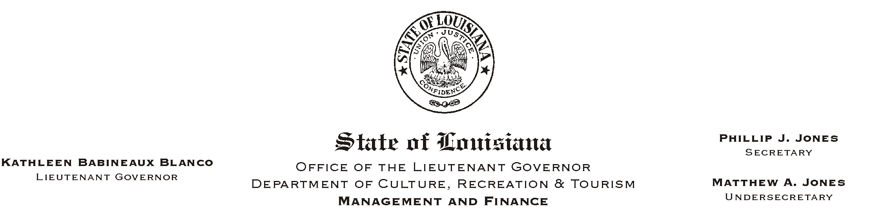

HUMAN RESOURCES MEMORANDUM NO. 03-060

June 25, 2003

TO: Lt. Governor, Secretary, Undersecretary, Assistant Secretaries, Deputy Assistant Secretaries, Program Managers

FROM: Mary F. Ginn
Human Resources Director

SUBJECT: New Benefit Plan Year Starts July 1, 2003
Some Insurance Cards Mailed – Others Delayed

The attached notice from the Office of Group Benefits (OGB) is a reminder about the new plan year starting July 1, 2003. It also notifies members of the OGB/EPO and OGB/PPO programs that their insurance cards will arrive shortly after July 1. Members of some plans have reported already receiving their cards while others have not. We checked with FARA (MCO) today and they have assured us that all insurance cards should be received by their members before July 1.

The notice from OGB also includes telephone numbers for all of the state’s insurance plans. Please note that the number for UnitedHealthcare (EPO in Region 6) has changed since we published the numbers during annual enrollment. Anyone who does not receive a new insurance card by July 1, 2003 should notify the appropriate insurance provider.

If you have any questions or concerns, please call the Human Resources Office at (225) 342-0880.

Attachment

Please Post and Circulate

